October 11, 2016

Specialized press contact
Dr. Ursula Keil
High Performance Polymers
Phone +49 2365-49-9878
Fax +49 2365-49-809878
ursula.keil@evonik.com

Evonik Resource Efficiency GmbH
Rellinghauser Strasse 1-11
45128 Essen
Germany
Phone +49 201 177-01
Fax +49 201 177-3475
www.evonik.com

Supervisory Board
Dr. Ralph Sven Kaufmann, Chairman

Management Board
Dr. Claus Rettig, Chairman
Dr. Johannes Ohmer,
Simone Hildmann,
Alexandra Schwarz

Registered Office: Essen
Register Court: Essen Local Court
Commercial Registry B 25783
VAT ID no. DE 815528487
Production of hybrid components in an automated process with VESTAMELT® Hylink

- New, shorter production chain
- Adhesion promoter from Evonik is indispensable for the innovative process
- Demonstration during K2016 at Wittmann Battenfeld in hall 16, stand D22
Announced at the K2010 six years ago and used for a series production part in 2013 for the first time, the production of plastic-metal hybrid components is now being taken to the next level with the copolyamide-based adhesion promoter VESTAMELT® Hylink: The Institute of Plastics Processing in Industry and the Skilled Crafts (IKV) at RWTH Aachen University has developed a process in which the deep drawing and overmolding of the metal component are combined in a single operation in the injection mold, thus automating production. This process necessitates an adhesive joining technique like that provided by VESTAMELT® Hylink.
Common process
Normally, metal and plastic parts of hybrid components are bonded using positive or non-positive connecting elements such as screws, rivets or injected form fits. A robust but relatively heavy solution requiring two work stations: The forming and painting of the metal part in the sheet metal processing unit and the joining with the injection-molded part in the plastic processing unit. Time and costs for cleaning and transportation between these two units must also be considered.
By contrast, the adhesion promoter VESTAMELT® Hylink firmly bonds the two components without a further joining technique. This reduces the weight by up to 20 percent and/or increases the performance of the component as compared with conventional solutions. So far, two work steps have also been needed here: Firstly, forming of the metal part coated with the copolyamide-based adhesion promoter and, secondly, overmolding and simultaneous bonding with the plastic component. These two processes are combined in the new innovative process. Forming, bonding, and overmolding take place in a single work step and with a single tool. Eliminating an entire production step reduces costs and the time needed for forming and transportation, and production can be fully automated.
Shorter process chain possible with VESTAMELT® Hylink
Development of the process entitled “Production of structural elements by means of deep drawing and overmolding in the injection mold” by the IKV, with funding from the Otto von Guericke Federation of Industrial Research Associations (grant no. IGF-18075N), was successfully completed with the use of the adhesion promoter VESTAMELT® Hylink, which creates an adhesive joint between metal and plastic in the mold. Polar plastics like polyamides or polyphthalamides are particularly suitable; PA6 and PA66 are frequently used. For improved mechanical properties after conditioning, Evonik offers bio-based VESTAMID® Terra polyamides 610 and 1010 as well as VESTAMID® HTplus polyphthalamide molding compounds for more demanding requirements with regard to temperature, chemical resistance, and low water absorption. This will further expand the range of applications—especially in structural components and other parts for the automotive industry and electronic engineering.
Live demonstration during K2016
Visitors to K2016 in Düsseldorf at stand D22 of exhibitor Wittmann Battenfeld GmbH in hall 16 can find out how the process works. Here, the fully automated process will be shown on a demonstrator that is derived from the cupping test. VESTAMELT® Hylink and VESTAMID® Terra HS1850, a polyamide 610 with 30 percent glass fibers, will be used for this.
More information can be found at www.vestamelt.com
Visit us during K2016 in Düsseldorf in hall 6, stand B28, and find out more about VESTAMELT® Hylink.

Caption:
The samples made from zinc-plated steel and VESTAMID® Terra from Evonik were deep-drawn, overmolded and adhesively bonded in a single production step using adhesion promoter VESTAMELT® Hylink.

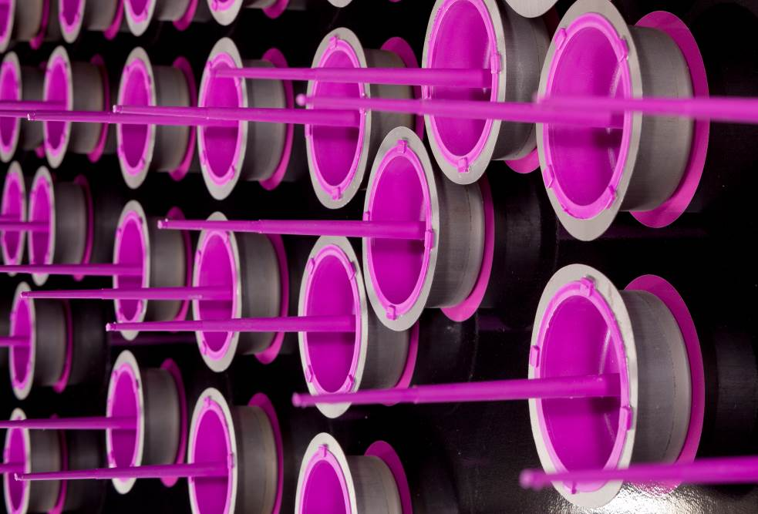

About Resource Efficiency
The Resource Efficiency segment is led by Evonik Resource Efficiency GmbH and supplies high performance materials for environmentally friendly as well as energy-efficient systems to the automotive, paints & coatings, adhesives, construction, and many other industries. This segment employed about 8,600 employees, and generated sales of around €4.3 billion in 2015.

About Evonik
Evonik, the creative industrial group from Germany, is one of the world leaders in specialty chemicals. Profitable growth and a sustained increase in the value of the company form the heart of Evonik’s corporate strategy. Its activities focus on the key megatrends health, nutrition, resource efficiency and globalization. Evonik benefits specifically from its innovative prowess and integrated Technology platforms.

Evonik is active in over 100 countries around the world. In fiscal 2015 more than 33,500 employees generated sales of around €13.5 billion and an operating profit (adjusted EBITDA) of about €2.47 billion.

Disclaimer
In so far as forecasts or expectations are expressed in this press release or where our statements concern the future, these forecasts, expectations or statements may involve known or unknown risks and uncertainties. Actual results or developments may vary, depending on changes in the operating environment. Neither Evonik Industries AG nor its group companies assume an obligation to update the forecasts, expectations or statements contained in this release.

