Rapidly molded sandwich components using ROHACELL®
March 21, 2012

Dr. Ursula Keil
Marketing Support
High Performance Polymers
Phone: +49 2365 49-9878
Fax: +49 2365 49-809878
ursula.keil@evonik.com

- In automotive construction, plastics offer weight advantages over metals as well as a high degree of design freedom.
- ROHACELL® structural foam from Evonik Industries, Essen, Germany, opens up many versatile and cost-effective possibilities for use in sandwich structures.

Weight saving options in automotive construction are far from exhausted: While metal still holds sway in automotive design, plastics are now offering cost-effective solutions in small- or medium-scale production, even for large-area parts such as exterior paneling, interior trim, and concealed bases/supports. The use of sandwich design also allows substantial weight savings of up to 60 percent. In this type of structure, face sheets of fiber-reinforced resins or thermoplastics are applied on a light but high-strength core.

High-performance ROHACELL® foam from Evonik is distinguished in this application by its high strength coupled with low weight and very high heat resistance. In cycle times of about two minutes, the foam core is thermally formed into the geometry required for the component, and is then quickly and very economically processed with, for example, high-performance resins at temperatures well above 130°C and high pressure.

In combination with fiber reinforced thermoplastic face sheets, ROHACELL® also offers another extremely cost-effective method for production of panels, with the finished part available in less than four minutes. The foam core is heated along with the thermoplastic face sheets and formed, and in the same operation the two are bonded together, cooled, and removed from the die.

Figure caption:

Sandwich components made from fiber-reinforced plastic face sheets and a ROHACELL® foam core allow substantial weight savings over metal components. The production process is fast and cost-effective.

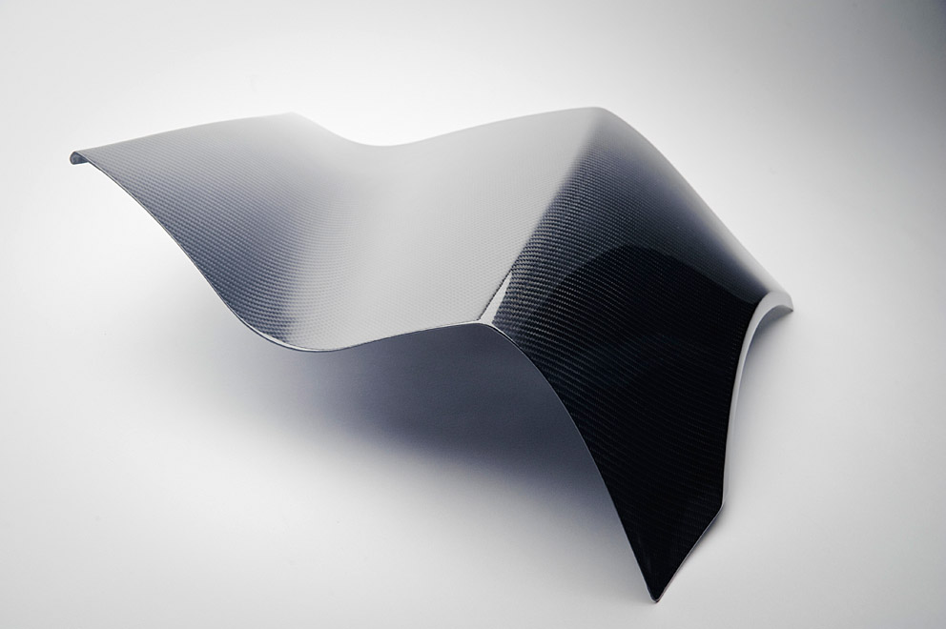

Company information
Evonik, the creative industrial group from Germany, is one of the world leaders
in specialty chemicals. Its activities focus on the key megatrends health, nutrition, resource efficiency and globalization. Profitable growth and a sustained increase in the value of the company form the heart of Evonik’s corporate strategy. Evonik benefits specifically from its innovative prowess and integrated technology platforms.

Evonik is active in over 100 countries around the world. In fiscal 2011 more than 33,000 employees generated sales of around €14.5 billion and an operating profit (EBITDA) of about €2.8 billion.

Disclaimer
In so far as forecasts or expectations are expressed in this press release or where our statements concern the future, these forecasts, expectations or statements may involve known or unknown risks and uncertainties. Actual results or developments may vary, depending on changes in the operating environment. Neither Evonik Industries AG nor its group companies assume an obligation to update the forecasts, expectations or statements contained in this release.

