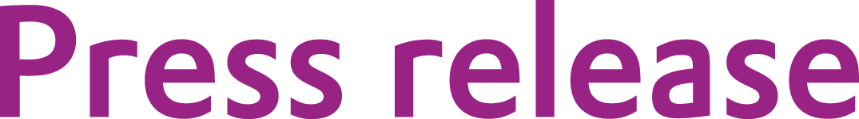
Evonik: Expanded capacity for isobornyl methacrylate

March 19, 2013

Contact person specialized press

Andrea Schäuffele
Performance Polymers
Phone +49 6151 18-4614
Fax +49 6151 18-844614
Andrea.schaeuffele@evonik.com
Evonik Industries AG
Rellinghauser Strasse 1-11
45128 Essen
www.evonik.com

Chairman of the Supervisory Board
Dr. Werner Müller
Executive Board
Dr. Klaus Engel, Chairman
Dr. Wolfgang Colberg,
Dr. Thomas Haeberle, Thomas Wessel,
Patrik Wohlhauser, Dr. Dahai Yu

Registered Office: Essen
Register Court: Essen Local Court
Commercial Registry B 19474
VAT ID no. DE 811160003

VISIOMER® IBOMA allows for production of eco-friendly, low-VOC coatings

Capacity increase of 20 percent

In response to the increased demand for low-VOC coatings, Evonik Industries has expanded its production capacities for VISIOMER® IBOMA in Germany by twenty percent.

VISIOMER® IBOMA (isobornyl methacrylate) is a specialty methacrylate that is primarily manufactured from a renewable resource. It is used, among other applications, for the manufacture of environmentally friendly high-solid clear coatings in the automotive industry. Further uses include reactive resin systems for adhesives, sealants, or composites.

The Acrylic Monomers Business Line of the Evonik Performance Polymers Business Unit produces and globally markets specialty methacrylates as well as MMA, GMAA, BMA and hydroxy methacrylates under the brand name VISIOMER®. In addition to VISIOMER® IBOMA, Evonik offers a wide range of innovative solutions for eco-friendly coating systems and technologies. These include the development product VISIOMER® GLYFOMA, which allows for formulating low-odor resin systems. The company's portfolio for the coatings industry is rounded off by further specialty methacrylates such as VISIOMER® MEEU (wet adhesion monomer), VISIOMER® EHMA (2-ethylhexyl methacrylate) and various amino methacrylates.

Company information

Evonik, the creative industrial group from Germany, is one of the world leaders in specialty chemicals. Profitable growth and a sustained increase in the value of the company form the heart of Evonik’s corporate strategy. Its activities focus on the key megatrends health, nutrition, resource efficiency and globalization. Evonik benefits specifically from its innovative prowess and integrated technology platforms.

Evonik is active in over 100 countries around the world. In fiscal 2012 more than 33,000 employees generated sales of around €13.6 billion and an operating profit (adjusted EBITDA) of about €2.6 billion.

Disclaimer
In so far as forecasts or expectations are expressed in this press release or where our statements concern the future, these forecasts, expectations or statements may involve known or unknown risks and uncertainties. Actual results or developments may vary, depending on changes in the operating environment. Neither Evonik Industries AG nor its group companies assume an obligation to update the forecasts, expectations or statements contained in this release.

