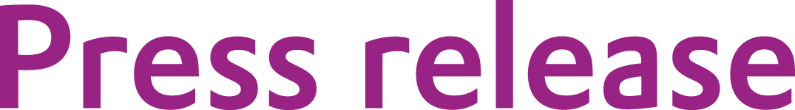
Evonik: Crosslinking additive boosts chemical resistance of coatings

March 19, 2013

Contact person specialized press

Horst-Oliver Buchholz
Advanced Intermediates
Phone +49 6181 59-13149
Fax +49 6181 59-713149
horst-oliver.buchholz@evonik.com
Evonik Industries AG
Rellinghauser Strasse 1-11
45128 Essen
www.evonik.com

Chairman of the Supervisory Board
Dr. Werner Müller
Executive Board
Dr. Klaus Engel, Chairman
Dr. Wolfgang Colberg,
Dr. Thomas Haeberle, Thomas Wessel,
Patrik Wohlhauser, Dr. Dahai Yu

Registered Office: Essen
Register Court: Essen Local Court
Commercial Registry B 19474
VAT ID no. DE 811160003

Proven crosslinking booster TAICROS® now also available for clear coatings

Improved resistance to chemicals and elasticity in UV-curing coatings

Evonik Industries is launching the successful crosslinking booster TAICROS® in a new application. As an additive in UV-curing clear coatings, TAICROS® produces excellent resistance to chemicals. Since the market is increasingly demanding eco-friendly alternatives to solvent-based coatings, UV-curing coatings are steadily gaining importance. Until now, the weak point of such coatings has been their less than optimal resistance to chemical impacts. TAICROS® offers improved results in this regard. Thanks to its chemical structure, the additive also provides higher elasticity, a property in high demand among coatings buyers.

TAICROS® is a reactive thinner with crosslinking properties under UV exposure. The product of the Advanced Intermediates Business Unit has been used in a wide range of applications in the plastic and rubber industry for ten years, for example in protective plastic films for photovoltaic cells. Evonik has now developed innovative formulations in a cooperative effort with Fraunhofer Institute that allow for improved performance of UV-curing clear coatings as well as electron-beam-curing coatings.

The TAICROS® product family includes a number of triazine-based crosslinking boosters of Evonik. All products are highly efficient, tri-functional crosslinking additives that are used for the peroxide and electron-beam crosslinking of a number of materials.

The Agrochemicals & Polymer Additives Business Line of the Advanced Intermediates Business Unit of Evonik Industries supplies custom-tailored solutions in attractive market segments, working successfully with customers in long-term one-on-one relationships.

Company information

Evonik, the creative industrial group from Germany, is one of the world leaders in specialty chemicals. Profitable growth and a sustained increase in the value of the company form the heart of Evonik’s corporate strategy. Its activities focus on the key megatrends health, nutrition, resource efficiency and globalization. Evonik benefits specifically from its innovative prowess and integrated technology platforms.

Evonik is active in over 100 countries around the world. In fiscal 2012 more than 33,000 employees generated sales of around €13.6 billion and an operating profit (adjusted EBITDA) of about €2.6 billion.

Disclaimer
In so far as forecasts or expectations are expressed in this press release or where our statements concern the future, these forecasts, expectations or statements may involve known or unknown risks and uncertainties. Actual results or developments may vary, depending on changes in the operating environment. Neither Evonik Industries AG nor its group companies assume an obligation to update the forecasts, expectations or statements contained in this release.

