July 15, 2016
Economic press contact
Silke Linneweber
Corporate Press
Phone +49 201 177-3389
Fax +49 201 177-3030
silke.linneweber@evonik.com
Evonik Industries AG
Rellinghauser Straße 1-11
45128 Essen
Germany
Phone +49 201 177-01
Telefax +49 201 177-3475
www.evonik.de

Supervisory Board
Dr. Werner Müller, Chairman
Executive Board
Dr. Klaus Engel, Chairman
Dr. Ralph Sven Kaufmann
Christian Kullmann
Thomas Wessel
Ute Wolf
Registered office Essen
Registered court
Essen local court
Commercial registry B 19474
VAT ID no. DE 811160003

Life cycle analyses have been performed for around
70 percent of Evonik's sales

- Plans to extend the analysis to 80 percent of external sales of the three chemical segments
- Years of experience of such methods

Essen. Evonik Industries has already conducted life cycle analyses of around 70 percent of external sales generated by its three chemical segments as part of the sustainability analysis of its businesses. The aim is to extend this to 80 percent. Thomas Wessel, the member of Evonik's Executive Board responsible for sustainability: "These analyses take account of our customers' rising demands on the sustainability of our products. At the same time life cycle analyses are the basis for operational and decision-making processes at Evonik.” Life cycle analyses make the environmental impact of products and processes more transparent. They enable the company to identify additional opportunities and potential risks, which enhances the sustainability profile of decisions.

Since 2009, the interdisciplinary Life Cycle Management team, which comprises scientists and engineers, has performed more than 100 life cycle analyses of products, processes and entire sites. Examples are amino acids for animal nutrition, and road markings based on DEGAROUTE® reactive resin. In addition, the experience of the LCM experts is used in the ongoing development of the methods used for such analyses, both nationally and internationally in conjunction with sustainability institutions such as the World Business Council for Sustainable Development (WBCSD).

A broad spectrum of methods
Evonik's procedure comprises a broad spectrum of methods, including life cycle assessments based on international standards (ISO 14040ff). Life cycle assessments comprise a cradle-to-grave analysis covering the environmental impact of products at all stages in their life cycle from the raw materials to disposal. Another area of application is life cycle-based calculation of the carbon footprint of products. In addition, cross-referencing of existing findings from life cycle assessments of comparable products and production sites are used, for example, by making adjustments for the country-specific energy mix of the same product at different production sites.

Sustainability analysis in research and development
Together with the LCM team and the Wuppertal Institute for Climate, Environment and Energy, Evonik's strategic innovation unit Creavis has developed the I2P3 (“idea to people, planet, profit”) innovation management process already in 2012. Along with economic considerations, this gives ecological and social aspects of sustainability an equal place in the innovation process for new products and processes.

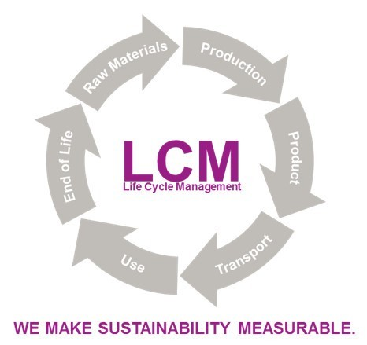

Caption:
Evonik Industries has already conducted life cycle analyses of around 70 percent
of external sales generated by its three chemical segments as part of the sustainability analysis of its businesses.

Company information
Evonik, the creative industrial group from Germany, is one of the world leaders
in specialty chemicals. Profitable growth and a sustained increase in the value of the company form the heart of Evonik’s corporate strategy. Its activities focus on the key megatrends health, nutrition, resource efficiency and globalization. Evonik benefits specifically from its innovative prowess and integrated technology platforms.
Evonik is active in over 100 countries around the world. In fiscal 2015 more than 33,500 employees generated sales of around €13.5 billion and an operating profit (adjusted EBITDA) of about €2.47 billion.

Disclaimer
In so far as forecasts or expectations are expressed in this press release or where our statements concern the future, these forecasts, expectations or statements may involve known or unknown risks and uncertainties. Actual results or developments may vary, depending on changes in the operating environment. Neither Evonik Industries AG nor its group companies assume an obligation to update the forecasts, expectations or statements contained in this release.

