Hybrid Components with VESTAMELT® Copolyamide Adhesion Promoters
March 17, 2010

Dr. Ursula Keil
Marketing Support
Phone +49 2365 49-9878
Fax +49 2365 49-809878
ursula.keil@evonik.com

Hybrid components made with the VESTAMELT® copolyamide adhesion promoter by Evonik Industries can absorb a greater amount of force in panels of the same thickness; that is, they are lighter given the same level of performance. With this innovative material solution Evonik is drawing on its long history of experience in bonding various materials, here plastics and metal.

Hybrid components made of metal and plastic, such as components like front-end support structures, roof and rear hatch reinforcing structures, not to mention compact, injection molding-sheathed components in joined areas of a vehicle’s body structure, are increasingly being used to improve lightweight design systems. The latest development is an adhesive system based on copolyamides, which markedly improves the bonding of steel and fiberglass-reinforced polyamides. Steel and polyphthalamide hybrid components and metal-to-metal bonding are possible, too.

Three ways are used to process the material:
As a granular material, it can be applied directly after the melting process. This means that no film has to be made beforehand, which would require additional energy input. As a powder, it can be applied using an electrostatic coating process, or it can be used as an adhesive in the coil coating process. The coating is storable, making it possible to process the component at a later time, such as outside the production cycle.

Components using the innovative VESTAMELT® primer system have a high degree of chemical resistance, are capable of withstanding heat and mechanical stress, can take cathodic dip coating, and can be welded together.

Evonik offers a broad range of raw and auxiliary materials for adhesives/bonding, providing the best possible support for connections in the vehicle. Bonding is one of several kinds of expertise provided by the specialty chemical company Evonik. The company’s Automotive Industry Team has pooled its bonding expertise under “Lightweight Design.”

Caption:
The Erlanger Träger (mounting) is an example to show the weight reduction by a thin-walled hybrid part with VESTAMELT®.

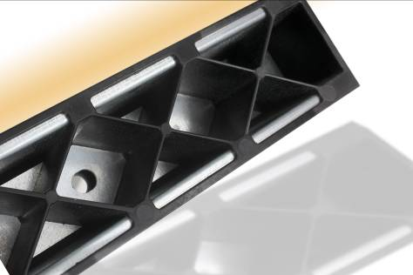

Company information
Evonik Industries is the creative industrial group from Germany which operates in three business areas: Chemicals, Energy and Real Estate. Evonik is a global leader in specialty chemicals, an expert in power generation from hard coal and renewable energies, and one of the largest private residential real estate companies in Germany. Our strengths are creativity, specialization, continuous self-renewal, and reliability. Evonik is active in over 100 countries around the world. In its fiscal year 2008 about 41,000 employees generated sales of about €15.9 billion and an operating profit (EBITDA) of about €2.2 billion.

Disclaimer

In so far as forecasts or expectations are expressed in this press release or where our statements concern the future, these forecasts, expectations or statements may involve known or unknown risks and uncertainties. Actual results or developments may vary, depending on changes in the operating environment. Neither Evonik Industries AG nor its group companies assume an obligation to update the forecasts, expectations or statements contained in this release.

