No contradiction: VESTAMID® HTplus both bio-based and high-performing
March 17, 2010

Dr. Ursula Keil
Marketing Support
Phone +49 2365 49-9878
Fax +49 2365 49-809878
ursula.keil@evonik.com

Polyphthalamide (PPA) is known for its outstanding performance at high temperatures and excellent mechanical properties. Essen, Germany-based Evonik Industries is now extending its range of VESTAMID® HTplus polyphthalamides to include a product group combining two special properties. Half of the raw materials on which the VESTAMID® HTplus M3000 line is based are renewable; moreover, the products offer improved processability and better dimensional and hydrolytic stability compared to conventional PPA molding compounds.

The VESTAMID® HTplus M3000 products are based on PA10T copolyamides. PA10T is a polycondensation product of 1,10-decamethylenediamine (10) and terephthalic acid (T); 1,10-decamethylenediamine is obtained from castor oil, so the PPA polymer is based up to 50 percent on renewable raw materials.

By contrast, well-known and commercially available polyphthalamides are based on petroleum-based PA6T chemistry. The new generation of PA10T polymers differs markedly from these in that they have a wider processing window, which simplifies handling. Moreover, VESTAMID® HTplus M3000 materials absorb much less water, which results in better dimensional stability and improved hydrolytic stability.

High-grade biological alternatives and favorable CO₂ balance
Demand for bio-based materials has increased significantly over the last few years due to ever-rising prices for petrochemical raw materials and because of customer concerns about sustainable conservation of resources. The CO₂ balance is one further plus point, being more favorable—if we consider the entire lifetime of the product—for VESTAMID® HTplus M3000 products than for exclusively petroleum-based polyamides. The product group therefore makes a significant contribution toward conserving fossil raw materials and reducing the greenhouse effect.

The entire VESTAMID® HTplus range includes injection-molding compounds for metal substitution and fire-proofing applications, granulates for filament production, and VESTAMID® HTplus R products, specially modified molding compounds that can be bonded to various rubbers without the need for adhesion promoters.

Figure caption:
Lower water absorption, increased dimensional stability, and improved elongation at break are what particularly distinguish VESTAMID® HTplus M3000 products from a standard PPA.

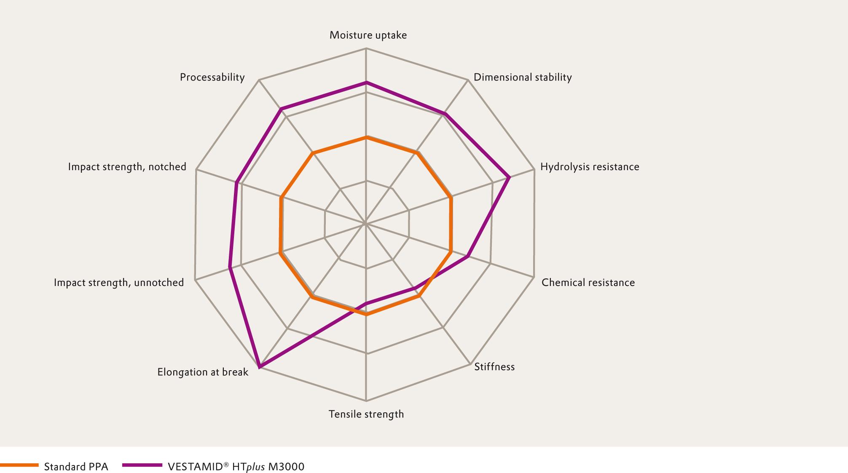

Company information
Evonik Industries is the creative industrial group from Germany which operates in three business areas: Chemicals, Energy and Real Estate. Evonik is a global leader in specialty chemicals, an expert in power generation from hard coal and renewable energies, and one of the largest private residential real estate companies in Germany. Our strengths are creativity, specialization, continuous self-renewal, and reliability. Evonik is active in over 100 countries around the world. In its fiscal year 2008 about 41,000 employees generated sales of about €15.9 billion and an operating profit (EBITDA) of about €2.2 billion.

Disclaimer

In so far as forecasts or expectations are expressed in this press release or where our statements concern the future, these forecasts, expectations or statements may involve known or unknown risks and uncertainties. Actual results or developments may vary, depending on changes in the operating environment. Neither Evonik Industries AG nor its group companies assume an obligation to update the forecasts, expectations or statements contained in this release.

