Color comes into play: coating materials with VESTOSINT® from Evonik gleam at Durban’s airport
July 22, 2010

Dr. Ursula Keil
Marketing Support
Phone +49 2365 49-9878
Fax +49 2365 49-809878
ursula.keil@evonik.com

Germany’s soccer team was not the only thing which drew a great deal of attention in Durban during the 2010 FIFA World Cup. The excellent quality of a coil coating for the new King Shaka Airport clearly turned heads, as well. And that is thanks in no small part to a product from Evonik in Essen, Germany — a polyamide 12 fine powder, VESTOSINT®.

The new international airport in Durban, one of South Africa’s ten World Cup venues, was commissioned on May 1, 2010 — not long before the tournament began. Designed for 7.5 million passengers, it also boasts a jetway for the new Airbus A380. A total of 12,000 liters of coil coating material in a modern and neutral shade of gray were used in constructing the airport’s façades and roofs made of steel. This coating material contains a unique additive: a polyamide 12 fine powder known as VESTOSINT®, which ensures a highly elastic structure resistant to abrasion. The polyamides are capable not only of absorbing even those forces which impact a coating suddenly, but also protecting the coating against cracking. Impact modifiers fulfill the same role in many plastics, some of which would otherwise be brittle. Furthermore, VESTOSINT® fine powder promotes excellent dirt repellency, which bears fruit particularly with regard to outdoor architectural use. The coating’s resistance to abrasion is enhanced because the polyamide particles—anchored in the coating by chemical bonds—cannot be dislodged by friction.

In stoving paints, polyamides bring about uniformly fine surface structures, which can be varied by means of the polyamide powder’s particle size distribution, as well as a mat surface gloss caused by the different refraction of coating resin and polyamide. The coatings contain no matting agents which could diminish weather resistance or elasticity. VESTOSINT® fine powders on offer vary as regards particle size and particle size distribution. They can be used individually or in a mixture to achieve the desired structure.

Figure caption:
The façades and roofs of the new King Shaka International Airport in Durban are well protected against abrasion, cracking and dirt by coil coating with VESTOSINT®. (Photo: Kieron Thwaites)
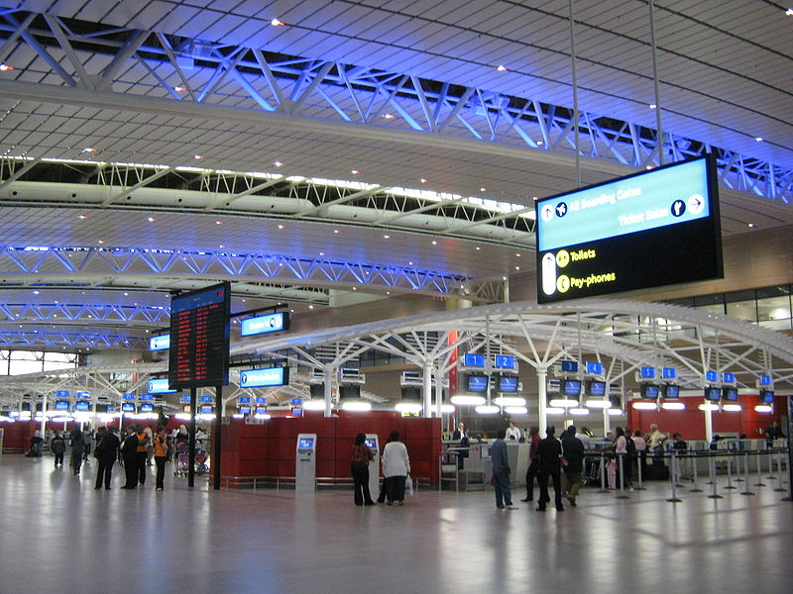

About Evonik
Evonik Industries is the creative industrial group from Germany. In our core business of specialty chemicals, we are a global leader. In addition, Evonik is an expert in power generation from hard coal and renewable energies, and one of the largest private residential real estate companies in Germany. Our company’s performance is shaped by creativity, specialization, continuous self-renewal, and reliability.

Evonik is active in over 100 countries around the world. In its fiscal year 2009 about 39,000 employees generated sales of about €13.1 billion and an operating profit (EBITDA) of about €2.0 billion.

Disclaimer
In so far as forecasts or expectations are expressed in this press release or where our statements concern the future, these forecasts, expectations or statements may involve known or unknown risks and uncertainties. Actual results or developments may vary, depending on changes in the operating environment. Neither Evonik Industries AG nor its group companies assume an obligation to update the forecasts, expectations or statements contained in this release.

