CyPlus GmbH Evonik Industries

Press Release
CyPlus GmbH

Rodenbacher Chaussee 4
63457 Hanau

Tel. +49-6181-59-6927
Fax +49-6181-59-6940

www.cyplus.com

July 31, 2026

Contact:
Dr. Edda Schulze

T +49-69-218-2712
F +49-69-218-62712

edda.schulze@evonik.com

CyPlus® commissions Cold Caro’s Acid Systems at Two of Jaguar Mining Inc.’s Sites in Brazil

CyPlus® has succeeded in commissioning two Cold Caro’s Acid systems for Concord, New Hampshire, USA-based Jaguar Mining Inc. at their Turmalina and Paciencia gold-mining operations in Brazil. The systems treat cyanide-containing effluent. Cold Caro’s Acid is a powerful oxidant that is produced in situ by adding hydrogen peroxide to concentrated sulfuric acid. It is used in gold extraction to convert cyanide into cyanate. “The CyPlus system is a proven process that achieves a yield of more than 80 percent of Cold Caro’s Acid,” says Stephen Gos, manager of Technology Solutions at CyPlus GmbH in Hanau-Wolfgang. The advantage of the CyPlus® system is that the heat from the reaction can be controlled and kept at low levels, thus ensuring safe operation.

A feasibility study conducted by CyPlus® in its laboratories in Germany shows that the Cold Caro’s Acid process outperforms other effluent-treatment systems. Basing its decision on the feasibility study and the basic engineering package, Jaguar choose to install the CyPlus® system for generating Cold Caro’s Acid. Besides keeping cyanide levels in check, the system is highly efficient as regards hydrogen peroxide and sulfuric acid consumption.

“We require low cyanide discharge levels for our operations and it is essential to perform this economically. With the CyPlus® Cold Caro’s Acid systems, we expect to reduce reagent consumption by more than 30%, achieving the same low cyanide levels of 10 ppm or better. The results from the commissioning phase indicate that we made the right choice,” says Mauro Salim, project manager for both of the Jaguar Mining operations.

This Cyplus® process is especially suitable for treating cyanide-containing effluents from ore processing operations in order to comply with stringent limits such as those set by the International Cyanide Management Code, the World Bank, and local authorities.
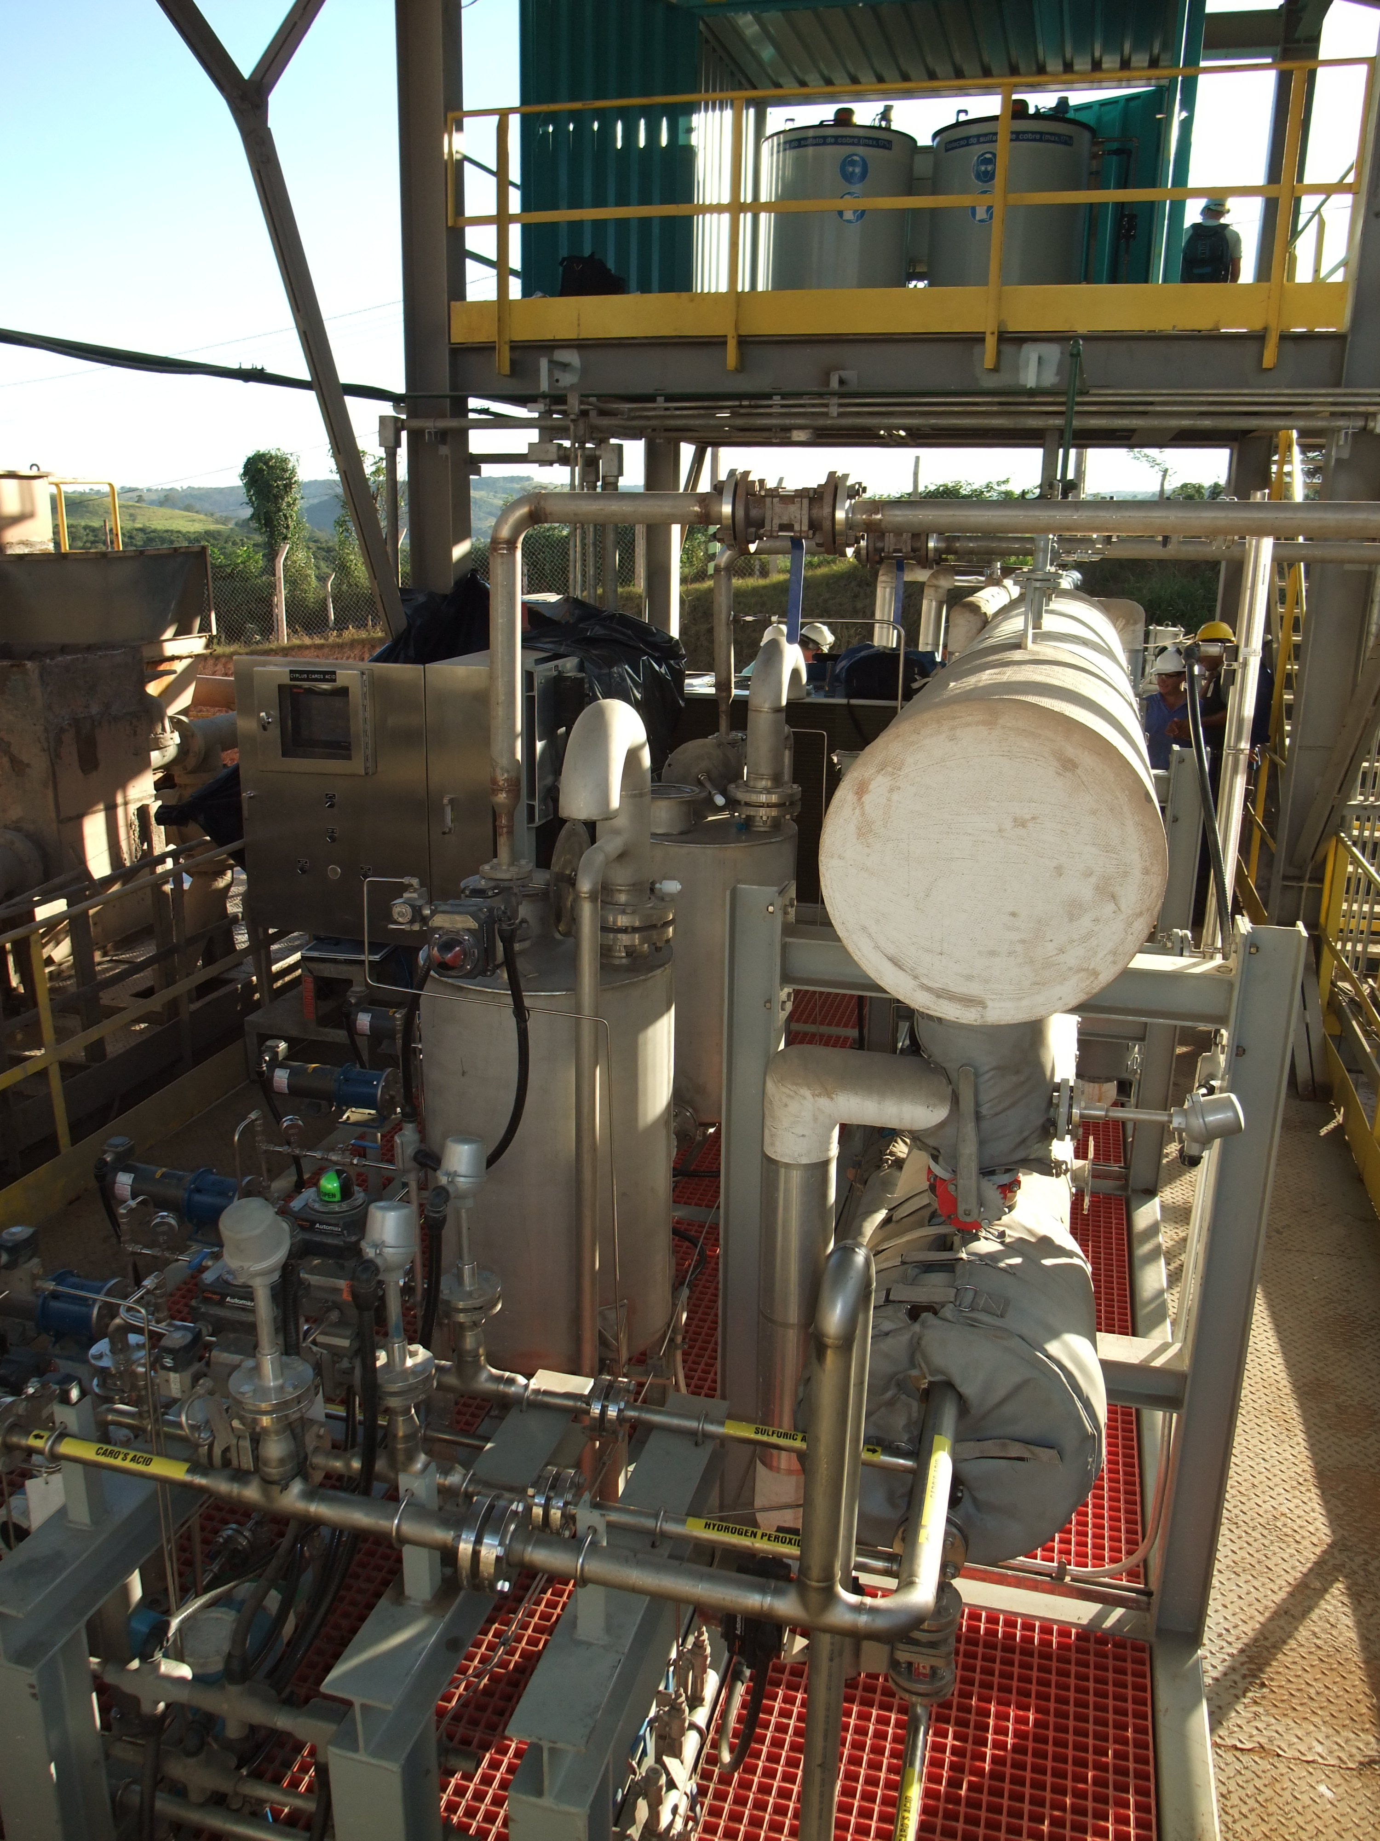

CyPlus® Cold Caro’s Acid system at the Turmalina gold mine, Brazil

CyPlus is a worldwide leading company in cyanides. The wholly owned Evonik group subsidiary supplies products to customers in the mining, chemical, pharmaceutical, and surface treatment industries. The company meets the extensive and strict requirements of the international gold mining industry as a supplier of cyanides in accordance with the provisions of the "International Cyanide Management Code" (ICMC). 60 employees worldwide, production sites in Europe and sales and distribution offices on all continents provide customers swift and reliable service. CyPlus regards itself as the pacesetter of progress and sustainability in the industry.

