Email from Your Plant:
Early-Warning Condition Monitoring System SR::SPC
October 13, 2009
Dr. Georg Händel
System Technologies
Phone +49 201 801-4110
Fax +49 201 801-4102
Mobil +49 175 2915810
georg.haendel@evonik.com

Urs Steinmetz
System Technologies
Phone +49 201 801-4030
Fax +49 201 801-4102
urs.steinmetz@evonik.com

Evonik Energy Services GmbH
System Technologies
Rüttenscheider Straße 1 - 3
45128 Essen
Phone +49 201 801-4000
Fax +49 201 801-4102
www.evonik.com/energyservices

Board of Management
Dr. Ralf Gilgen, Chairman
Wolfgang von Heesen,
Dr. Matthias Schwara

Registered Office Essen
Register Court
Essen Local Court
Commercial Registry B 1985

• SR::SPC proactively signals changes of the plant performance in the Luenen power plant

To support the operators in the power plant Luenen more than 50 so called “Key Performance Indicators” (KPI) are continuously supervised with help of statistical process analysis. The KPIs are evaluated for important equipment and process parameters to detect statistically significant deviations from their individual reference values.

The rating of the current plant performance requires the continuous analysis of the main components and of relevant process parameters (like efficiency). Changes of the load requirements and of environmental conditions are reflected in changes of the operating data. A direct judgement on the plant performance therefore becomes difficult or impossible. This is especially true if several measurements must be evaluated together with their interdependencies. In this situation a sensitive IT-based early-warning system that was developed by Evonik Energy Services GmbH will now deliver the required support: SR::SPC continuously supervises the most important operating parameters of the plant.

Central for the rating of the plant performance are the “Key Performance Indicators”. They are derived from the current status and the corresponding reference values and are a measure of equipment and process performance.

To cope with changing operating conditions SR::SPC calculates the reference values with help of physical models or with trained neuronal networks. Current operation conditions (load, fuel quality, feed water temperature etc.) are input into the calculations. The result therefore is not just a “theoretical value” but is in fact achievable in the current moment. Variations in the measured data are reflected in correlated variations of the KPI values. Alarm limits therefore are either set too wide and the system notifies changes “too late” especially if the values are drifting slowly or – with limits set too narrow – produces false alarms thereby reducing the acceptance of the system.

To solve these issues statistical calculation methods that are specialized on the analysis of continuous measurements are used in a second stage after the KPI calculation and achieve two different aims: false alarms are reliably suppressed and SR::SPC notifies very early.

In the Luenen power plant the SR::SPC system is in practical use since one year and has already signalled several otherwise difficult to detect deviations of the plant performance. For example a change of the condenser efficiency was detected which only occurred under partial load operation and was superimposed by other effects. The early notification will be automatically sent by email to the person responsible for the equipment such that he can initiate corrective action in good time. In addition the slow increase of vibration monitoring signals of a fan has been signalled 3.5 month before hitting the first warning level in the control system. The required maintenance measures therefore could be moved to a planned outage period.

The early and reliable signalling and correction of such issues increase the average plant efficiency and availability and therefore contribute significantly to the commercial optimization of plant operation.

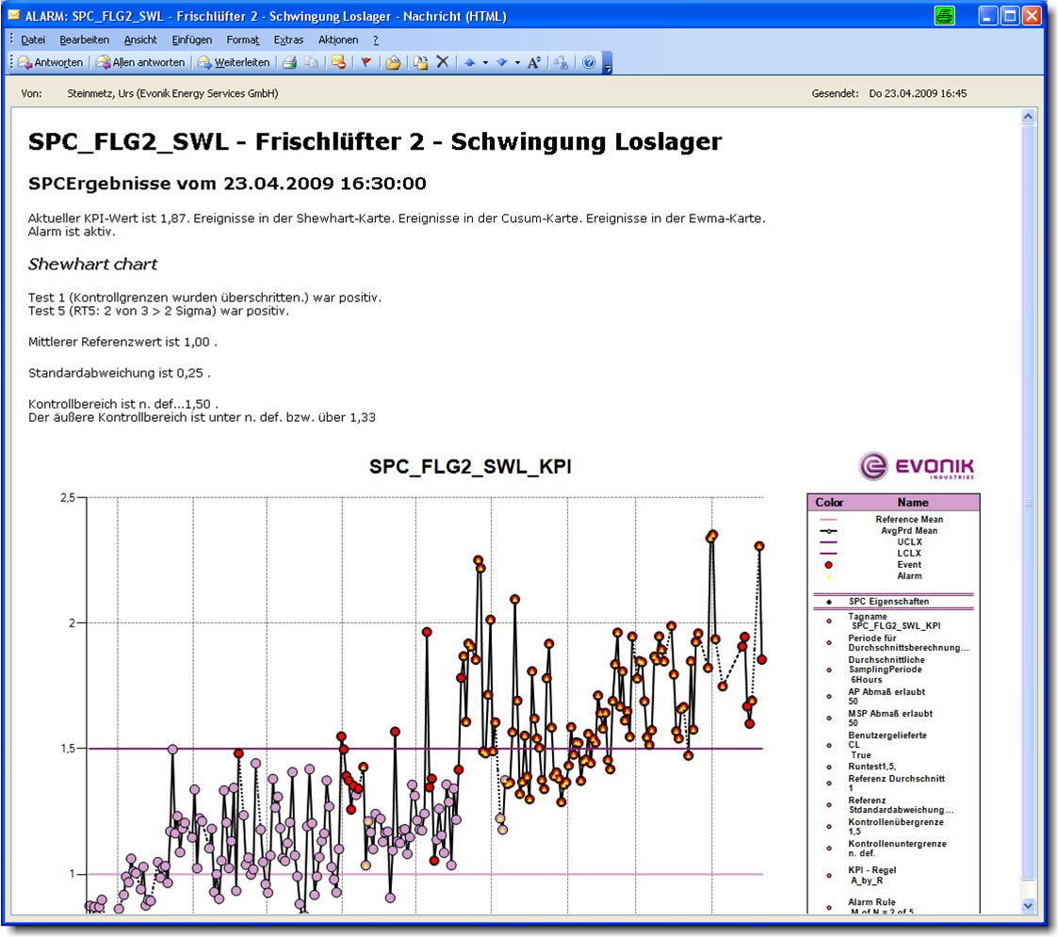

Email from the fan with results of the SR::SPC analysis

Company information
Evonik Industries is the creative industrial group from Germany which operates
in three business areas: Chemicals, Energy and Real Estate. Evonik is a global
leader in specialty chemicals, an expert in power generation from hard coal
and renewable energies, and one of the largest private residential real estate
companies in Germany. Our strengths are creativity, specialization, continuous
self-renewal, and reliability.

Evonik is active in over 100 countries around the world. In its fiscal year 2008
about 41,000 employees generated sales of about €15.9 billion and an operat- ing profit EBITDA of about €2.2 billion.

Disclaimer
In so far as forecasts or expectations are expressed in this press release or where
our statements concern the future, these forecasts, expectations or statements
may involve known or unknown risks and uncertainties. Actual results or devel-opments may vary, depending on changes in the operating environment. Neither
Evonik Industries AG nor its group companies assume an obligation to update
the forecasts, expectations or statements contained in this release.

