Power Plant Luenen:
October 13, 2009
Frank Bruderreck
System Technologies
Phone + 49 201 801-4042
Fax +49 201 801-4102
Mobile +49 173 5451098
frank.bruderreck@evonik.com

Dr. Martin Stephan
System Technologies
Phone +49 201 801-4109
Fax +49 201 801-4102
Mobile+49 163 8012030
martin.stephan@evonik.com
Evonik Energy Services GmbH
System Technologies
Rüttenscheider Straße 1 - 3
45128 Essen
Phone +49 201 801-4000
Fax +49 201 801-4102
www.evonik.com/energyservices

Board of Management
Dr. Ralf Gilgen, Chairman
Wolfgang von Heesen,
Dr. Matthias Schwara

Registered Office Essen
Register Court
Essen Local Court
Commercial Registry B 1985
Europe’s Largest Application of Stress Wave Analysis in Operation

• Stress Wave Analysis of plant equipment delivers important information about status and operating conditions

In the Luenen power plant of Evonik Steag GmbH the currently largest application of stress wave analysis in Europe has been taken into operation. With nearly 100 sensors 38 main equipment units are continuously supervised on their “health status”.

Stress Wave Analysis (SWAN TM) is an ultrasonic instrumentation and analysis technique for the quantitative measurement of dynamic contact stresses between moving parts in operating machinery. It was originally developed to identify abnormal sources and causes of friction and shock such as damaged gears and bearings in kinematically complex gearboxes, where vibration analysis proved to be impractical.

The wide spread use of stress wave analysis at the Luenen power plant gives the operator the ability to continuously supervise the “health status” of the machines and puts him into the position to exploit abrasion reserves of his equipment through changes of plant operation and related maintenance, while simultaneously preventing unplanned outages. The corresponding reduction of the number of unplanned shutdowns are reflected in significant financial savings.

To understand the methodology of stress wave analysis a comparison with health care is helpful: An EKG is used to understand how the human body responds to changes in the external environment. Under load, there is an expectation that stress levels will rise and will fall when the load conditions stop. For humans and machines alike: the earlier the detection, the greater the probability of successfully managing that condition.

The key feature computed is the Stress Wave Energy (SWE TM). SWE is directly proportional to the friction between moving parts that are separated by a lubricant boundary layer. Since friction is a function of both speed and load, SWAN TM is an excellent method for understanding the dynamic loading and lubrication condition in operating machinery, as well as detecting classic rolling element defect, imbalance, et al.

Aside the usage in power plants SWAN TM systems are currently deployed across a broad array of industries and applications, ranging from cruise ships to process industry applications, from high speed gas turbines to low speed wind turbines; and most recently in gas pipelines, detecting internal leakage in valves.

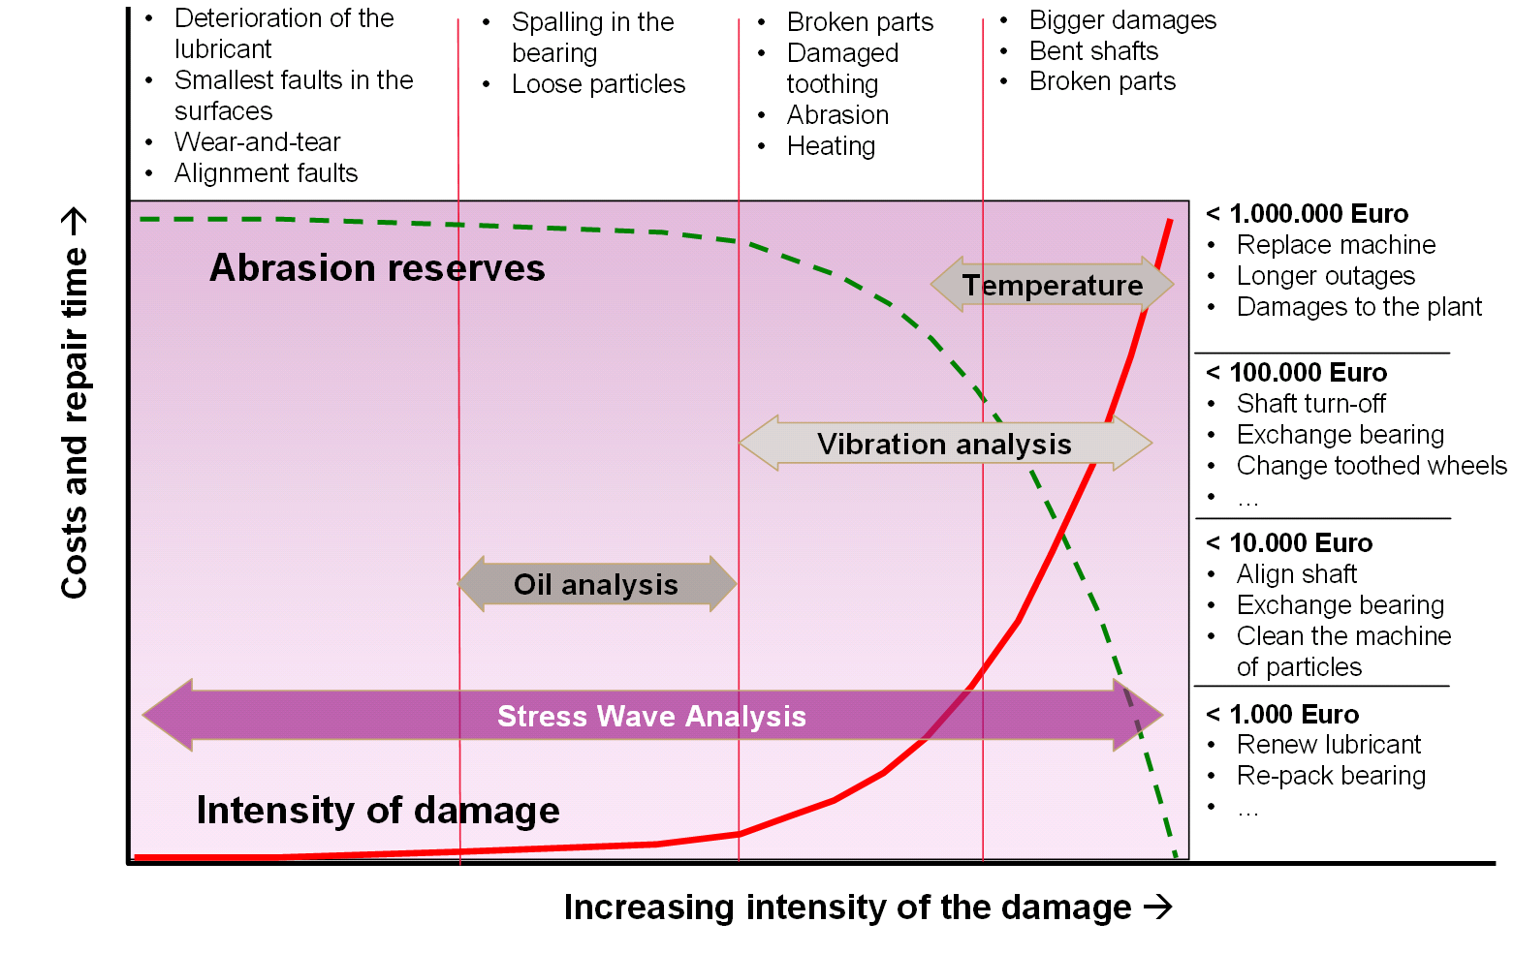

From all condition monitoring systems Stress Wave Analysis provides the earliest possible detection of damage processes

Company information
Evonik Industries is the creative industrial group from Germany which operates
in three business areas: Chemicals, Energy and Real Estate. Evonik is a global
leader in specialty chemicals, an expert in power generation from hard coal
and renewable energies, and one of the largest private residential real estate
companies in Germany. Our strengths are creativity, specialization, continuous
self-renewal, and reliability.

Evonik is active in over 100 countries around the world. In its fiscal year 2008
about 41,000 employees generated sales of about €15.9 billion and an operat- ing profit EBITDA of about €2.2 billion.

Disclaimer
In so far as forecasts or expectations are expressed in this press release or where
our statements concern the future, these forecasts, expectations or statements
may involve known or unknown risks and uncertainties. Actual results or devel-opments may vary, depending on changes in the operating environment. Neither
Evonik Industries AG nor its group companies assume an obligation to update
the forecasts, expectations or statements contained in this release.

