Mobile Maintenance for Power Plants:
Award-Winning Solution of Evonik Interfaces to SAP as well
October 13, 2009
Dr. Martin Stephan
System Technologies
Phone +49 201 801-4109
Fax +49 201 801-4102
Mobile+49 163 8012030
martin.stephan@evonik.com

Frank Bruderreck
System Technologies
Phone + 49 201 801-4042
Fax +49 201 801-4102
Mobile +49 173 5451098
frank.bruderreck@evonik.com

Evonik Energy Services GmbH
System Technologies
Rüttenscheider Straße 1 - 3
45128 Essen
Phone +49 201 801-4000
Fax +49 201 801-4102
www.evonik.com/energyservices

Board of Management
Dr. Ralf Gilgen, Chairman
Wolfgang von Heesen,
Dr. Matthias Schwara

Registered Office Essen
Register Court
Essen Local Court
Commercial Registry B 1985

• Maintenance and Equipment Isolation with RFID

Since a few years Evonik power plants use mobile devices and RFID-chips that are attached to the individual equipment units to support maintenance and deactivation/reactivation activities directly on site. In March 2009 this solution has been awarded the prize „Maintainer 2009“ in the category „project of the year: service provider“ by the consulting company T. A. Cook in collaboration with BASF, BP, Hydro Aluminium and Infracor.

As current enhancement the solution for mobile maintenance now also interfaces directly to SAP without use of the xMAM module. This system structure gives the universally applicable standard solution a high investment security.

The integral solution of Evonik Energy Services GmbH provides mobile support for maintenance, service, deactivation/ reactivation, meter readings and round tours directly at the plant equipment and is interfaced to the SAP-system. The reduction of the number of interfaces pays back by needing less time for installation and commissioning of this standard solution and for later system support.

In the past the support of work tasks often ended in the supervisor’s office. With help of PDAs (Personal Digital Assistants) the computerized maintenance system now extends to the equipment in the plant. A RFID-Chip attached to the equipment is used to uniquely identify the individual equipment on site and automatically displays the work tasks at hand. Important information related to the maintenance and deactivation activities are recorded on the RFID-chip.

On the occasion of the “MainDays” congress the mobile solution of Evonik Energy Services GmbH has been awarded the prize “Maintain 2009”. A jury with notable members recognized the advantages of the system that simplify the work at the technical equipment and improve the work safety at the same time.

As autonomous frontend-system the mobile component of Evonik can be couple to any backend-system. A direct interface to SAP (for which the use of the native SAPxMAM-solution has been omitted) results in short time for commissioning, gives convincing performance during synchronization and for the user interface and requires only a small amount of customization of SAP. In addition the support costs for continuous operation are kept low.

If a customer doesn’t use any maintenance system Evonik can supply SI® as backend-system together with the mobile component which in this combination covers all needs of maintenance and technical plant operation and is supplied from one source.

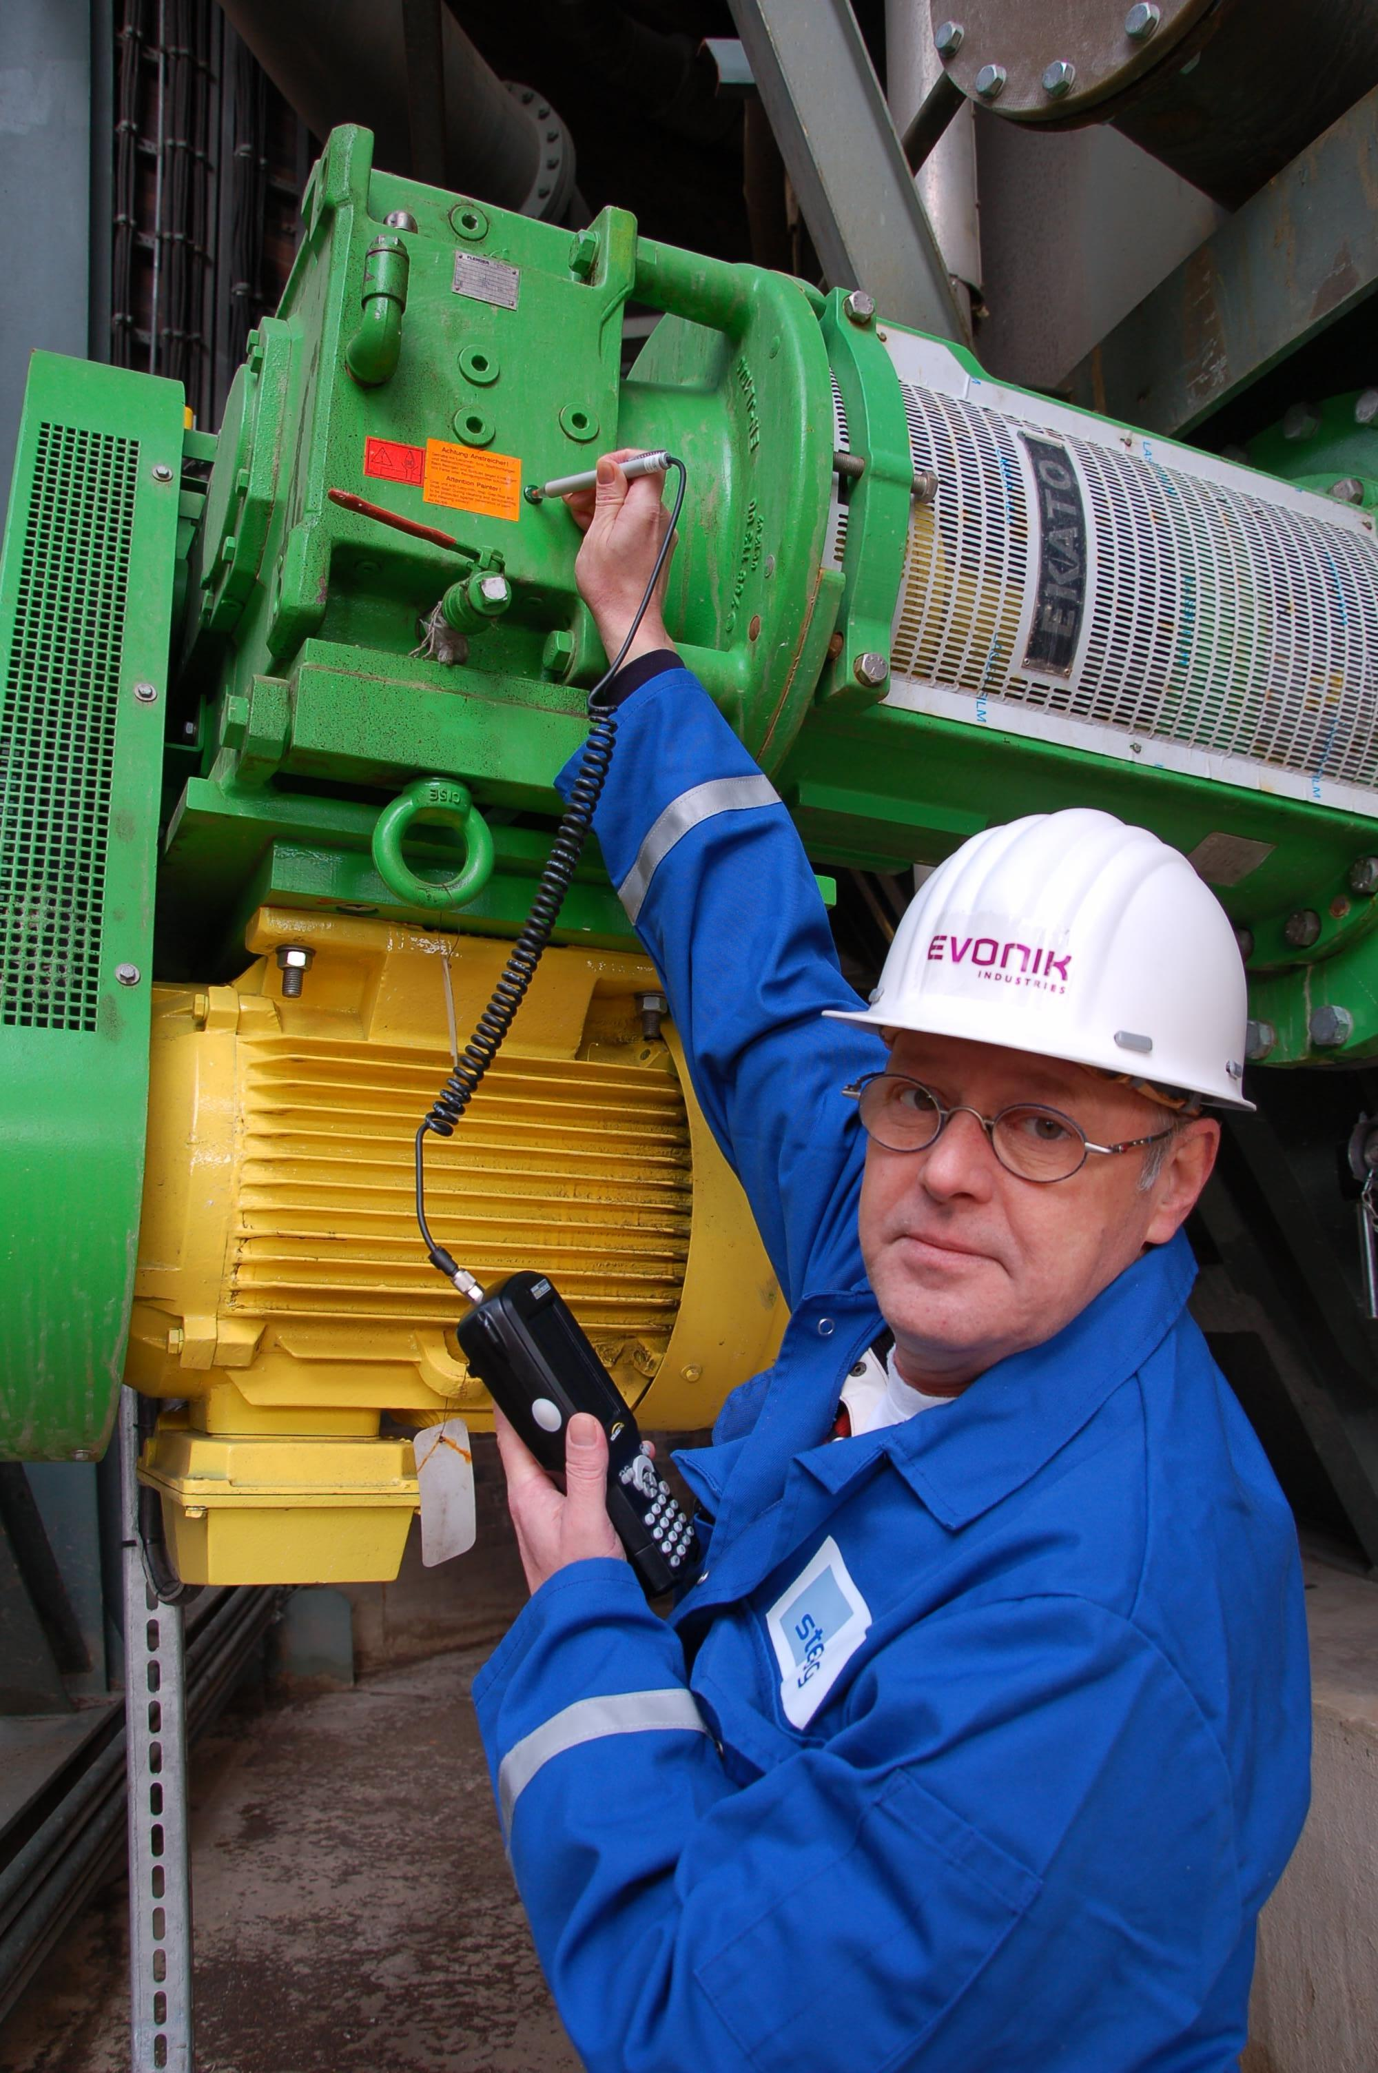

Usage of RFID-chips for maintenance

Company information
Evonik Industries is the creative industrial group from Germany which operates
in three business areas: Chemicals, Energy and Real Estate. Evonik is a global
leader in specialty chemicals, an expert in power generation from hard coal
and renewable energies, and one of the largest private residential real estate
companies in Germany. Our strengths are creativity, specialization, continuous
self-renewal, and reliability.

Evonik is active in over 100 countries around the world. In its fiscal year 2008
about 41,000 employees generated sales of about €15.9 billion and an operat- ing profit EBITDA of about €2.2 billion.

Disclaimer
In so far as forecasts or expectations are expressed in this press release or where
our statements concern the future, these forecasts, expectations or statements
may involve known or unknown risks and uncertainties. Actual results or devel-opments may vary, depending on changes in the operating environment. Neither
Evonik Industries AG nor its group companies assume an obligation to update
the forecasts, expectations or statements contained in this release.

