FAKUMA 2009, Hall A4, Booth 4117
October 13, 2009

Doris Hirsch
Marketing Services
Molding Compounds

Evonik Röhm GmbH
Phone +49 6151 18 4079
Fax +49 6151 18 3177
doris.hirsch@evonik.com

PLEXIMID® TT70: Crystal-Clear for Headlamp Lenses
- Specialty molding compound with high heat deflection temperature and good optical properties
- High transmission, low yellowness index and low haze even after long-term heat exposure

Darmstadt - The specialty molding compound PLEXIMID® TT70 (polymethyl methacrylimide) with a high heat deflection temperature is now available for light guides and lenses in modern automotive headlamps. This further development of PMMA durably retains the latter's excellent optical properties even at temperatures up to 150 degrees Celsius, providing headlamp lens manufacturers with a material that can withstand the high heat load of powerful xenon and LED lamps while enabling dynamic styling.

High light transmission, low yellowness index and low haze
At over 90%, the light transmission of PLEXIMID® TT70 remains virtually unchanged even after forty days' storage at 150 degrees Celsius and thus provides constantly high luminous efficiency. The transmittance of the comparative plastic polycarbonate (PC) and its heat-resistant variant PC-HT deteriorates visibly after storage under similar conditions.

Whereas the highest possible transmission is an advantage, the yellowness index should be as low as possible. At the end of the test period, PLEXIMID® TT70 continues to show a very low value. Not so PC-HT and PC: The pronounced yellowing of these materials makes the light appear dull.

The lower the clouding (haze value), the lower the light diffusion losses. PLEXIMID® TT70 provides constantly clear results. In the forty-day long-term exposure test at 150 degrees Celsius, clouding remains at almost the same level and is significantly lower than in comparative products.

Owing to its stable optical properties upon permanent exposure to heat and its flexible formability, PLEXIMID® TT70 is highly suitable for a variety of components in headlamp lenses, such as lens systems, light-guiding elements for parking and dipped headlights, light guides for turn signal lights and headlamps, and turn signal lamp covers.

Caption:
PLEXIMID® TT70 for highly transparent light-guiding elements in automotive headlamps

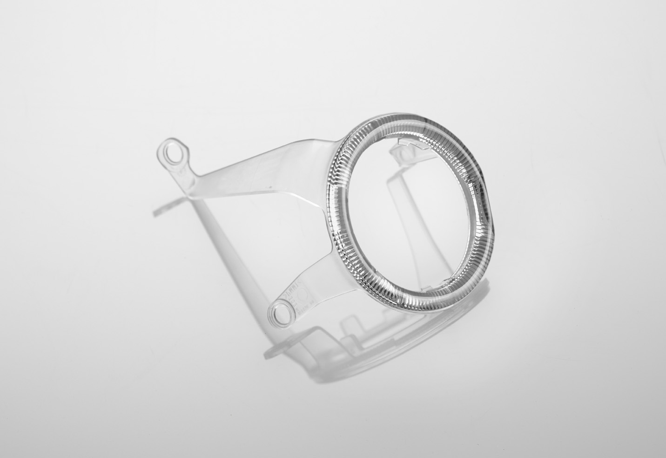

The Performance Polymers Business Unit of Evonik Industries is a worldwide manufacturer of PMMA and PMMI products sold under the PLEXIGLAS® and PLEXIMID® trademarks on the European, Asian, African and Australian continents and under the trademarks ACRYLITE® and ACRYMIDE® in the Americas.

Company information
Evonik Industries is the creative industrial group from Germany which operates in three business areas: Chemicals, Energy and Real Estate. Evonik is a global leader in specialty chemicals, an expert in power generation from hard coal and renewable energies, and one of the largest private residential real estate companies in Germany. Our strengths are creativity, specialization, continuous self-renewal, and reliability. Evonik is active in over 100 countries around the world. In its fiscal year 2007 about 43,000 employees generated sales of about €14.4 billion and an operating profit (EBITDA) of more than €2.2 billion.

Disclaimer
In so far as forecasts or expectations are expressed in this press release or where our statements concern the future, these forecasts, expectations or statements may involve known or unknown risks and uncertainties. Actual results or developments may vary, depending on changes in the operating environment. Neither Evonik Industries AG nor its group companies assume an obligation to update the forecasts, expectations or statements contained in this release.

