More Than 300 VESTAMID® Offshore Lines in Three Years
November 3, 2009

Dr. Ursula Keil
Marketing Support High Performance Polymers
Phone +49 2365-49-9878
Fax +49 2365-49-5992
ursula.keil@evonik.com

Since its approval in mid-2006, VESTAMID® LX9020, a polyamide 12 molding compound made by Essen, Germany-based Evonik Industries, has been used in the manufacture of more than 300 non-bonded flexible pipes in the oil industry. Oil companies are already using the pipes in offshore projects.

The molding compound was tested over a two-and-a-half year period between 2003 and 2006. These studies confirmed its advantageous properties over other polyamides used as barrier layers in flexible piping, properties that are crucial to the compound’s success. In collaboration with Wellstream International Limited, Evonik has conducted intensive tests to demonstrate compliance with the international standards API 17J (for flexible pipes) and ISO 13628-2. The tests evaluated creep performance, ductility, thermal expansion, methanol compatibility, and hydrolysis resistance as plus points. On the basis of these results, Lloyd’s Register granted Wellstream approval in June 2006 for the use of the polyamide 12 molding compound VESTAMID® LX9020 in the manufacture of flexible pipes for conveying production and injection fluids in offshore crude oil production, giving the company the award of the Certificate of Material Qualification for the Use of Polyamide 12 Grade VESTAMID® LX9020 in Non-Bonded Flexible Pipes.

Since then, the molding compound has been used commercially for the manufacture of flexible pipes. The polyamide 12 grade specially developed for the purpose combines the above technical advantages with extraordinarily consistent product quality; this ensures outstanding processability, thereby reducing setup times, scrap, and the risk of extrusion faults.

For decades, Evonik has been a leader in the development and marketing of high-grade polyamide compounds for line systems in motor vehicles. This high degree of expertise in the development of extrusion compounds has now been carried over to molding compounds for thick-walled piping systems; these are increasingly coming into use in the oil and gas industries, thanks to their advantages over existing systems.
Figure caption: The new polyamide 12 grade VESTAMID® LX9020 was developed specifically for offshore applications.

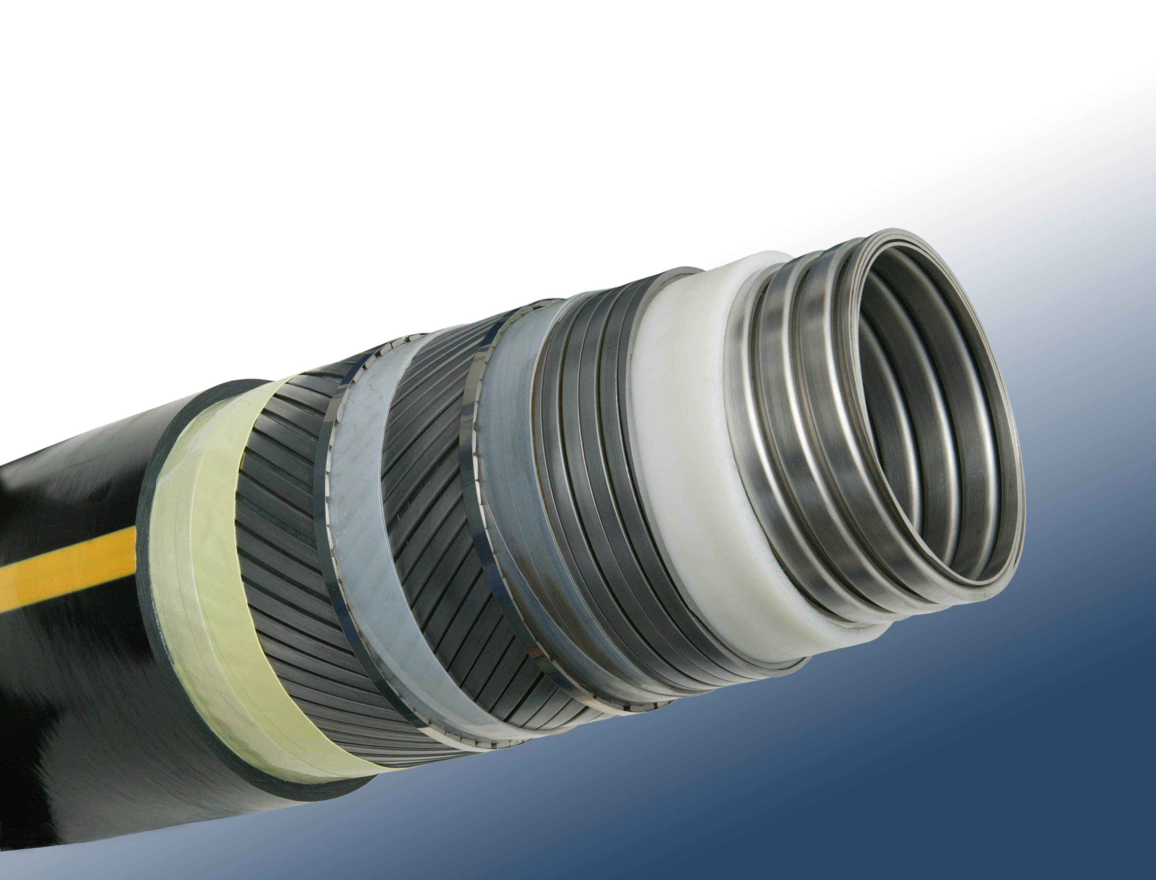

Company information
Evonik Industries is the creative industrial group from Germany which operates in three business areas: Chemicals, Energy and Real Estate. Evonik is a global leader in specialty chemicals, an expert in power generation from hard coal and renewable energies, and one of the largest private residential real estate companies in Germany. Our strengths are creativity, specialization, continuous self-renewal, and reliability. Evonik is active in over 100 countries around the world. In its fiscal year 2008 about 41,000 employees generated sales of about €15.9 billion and an operating profit (EBITDA) of about €2.2 billion.

Disclaimer

In so far as forecasts or expectations are expressed in this press release or where our statements concern the future, these forecasts, expectations or statements may involve known or unknown risks and uncertainties. Actual results or developments may vary, depending on changes in the operating environment. Neither Evonik Industries AG nor its group companies assume an obligation to update the forecasts, expectations or statements contained in this release.

