Press Release

CoverForm® Competence Center Opens for Hands-On Innovation

- New competence center for injection-molded plastic parts with a functional surface in Darmstadt
- Cooperation between KraussMaffei and Evonik Industries

Darmstadt, Germany.- In cooperation with machine builders KraussMaffei, Evonik Industries has achieved a milestone in plastics processing ‒ the CoverForm® system solution that enables the manufacture of injection-molded plastic components with a functional surface in just one step. The CoverForm® Competence Center was opened in Darmstadt on Novermber 18, 2009, and offers a hands-on experience of this highly innovative process. “With CoverForm® we are introducing a future technology together with KraussMaffei that is the result of a successful development cooperation arrangement,” said Gregor Hetzke, President of the Performance Polymers Business Unit of Evonik Industries at the inauguration of the CoverForm® Competence Center. KraussMaffei developed the machine technology for the process, based on the company’s extensive expertise in injection-molding and reaction technology. Evonik developed the required product combination of a specialty PLEXIGLAS® molding compound (PLEXIGLAS® cf molding compound) and a precisely adjusted multi-component solvent-free reactive system on an acrylate base for the functional coating. Dr. Karlheinz Bourdon, Managing Director of KraussMaffei, emphasized at the opening ceremony: “Together, we two partners have developed an entirely new, integrated process named CoverForm®, which enables us to offer a very convincing solution to our customers that significantly reduces the production costs of transparent components with a scratch-resistant coating.”

The new CoverForm® system solution substantially cuts the fabrication costs for scratch-resistant and chemical-resistant plastic components since they require no subsequent time-consuming and costly coating. CoverForm® produces plastics parts that are ready for installation when they leave the injection machine. At the trade show MATERIALICA, CoverForm® therefore received this year’s MATERIALICA Design & Technology Award and the “Best of Award” in the category Surface & Technology. CoverForm® is of interest wherever the aim is to achieve particularly high surface functionality, like scratch resistance. This may involve applications in the automotive and lighting industries, in optics or in communications and display applications.

Plastics fabricators can now experience the process for themselves at the new CoverForm® Competence Center in Darmstadt. But the center has even more to offer. “We will also use the competence center to further develop reactive systems,” explained Sven Schröbel, CoverForm® Project Manager at Evonik. “New antireflective or electrically conductive coatings are also conceivable, for instance. And we intend to train our global technical service staff at the CoverForm® Competence Center too.”

As a first step, CoverForm® will be launched on the European market. The USA and Asia will follow from 2010.

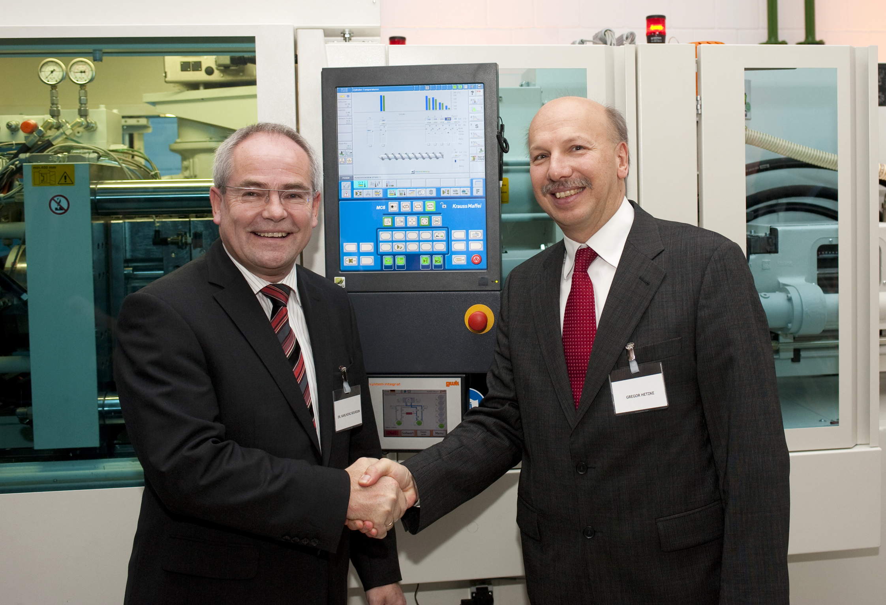
Dr. Karlheinz Bourdon Managing Director of KraussMaffei (left) and Gregor Hetzke, President of the Performance Polymers Business Unit of Evonik Industries at the inauguration of the CoverForm® Competence Center in Darmstadt, Germany.

For more information: www.coverform.com or Mail to info@coverform.com

The Performance Polymers Business Unit of Evonik Industries is a worldwide manufacturer of PMMA products sold under the PLEXIGLAS® trademark on the European, Asian, African and Australian continents and under the trademark ACRYLITE® in the Americas.

Contacts for the press:
Doris Hirsch  Marketing Services Molding Compounds  Evonik Röhm GmbH  Phone.: +49 – 6151 – 18 4079  Fax: +49 – 6151 – 18 3177  Mail: doris.hirsch@evonik.com | Matthias Andreesen Viegas  Head of Communications  KraussMaffei AG  Phone.: +49 - 89 - 8899 2592  Fax:+49 89 8899 3092  Mail: matthias.andreesen@kraussmaffei.com

Evonik Company information
Evonik Industries is the creative industrial group from Germany which operates in three business areas: Chemicals, Energy and Real Estate. Evonik is a global leader in specialty chemicals, an expert in power generation from hard coal and renewable energies, and one of the largest private residential real estate companies in Germany. Our strengths are creativity, specialization, continuous self-renewal, and reliability. Evonik is active in over 100 countries around the world. In its fiscal year 2008 about 41,000 employees generated sales of about €15.9 billion and an operating profit (EBITDA) of about €2.2 billion.

Disclaimer

In so far as forecasts or expectations are expressed in this press release or where our statements concern the future, these forecasts, expectations or statements may involve known or unknown risks and uncertainties. Actual results or developments may vary, depending on changes in the operating environment. Neither Evonik Industries AG nor its group companies assume an obligation to update the forecasts, expectations or statements contained in this release.

___________________________________________________________________________

KraussMaffei company profile
In terms of sales, KraussMaffei is world market leader in machines and systems for plastics and rubber processing. With its three divisions – Injection Moulding Technology, Extrusion Technology and Reaction Process Machinery – KraussMaffei is a premium partner for the plastics and rubber processing industries worldwide.
The group markets its products under the KraussMaffei, KraussMaffei Berstorff and Netstal brands. The KraussMaffei brand covers the whole spectrum of injection and reaction moulding technology, while the KraussMaffei Berstorff brand stands for successful extrusion solutions. The injection moulding machines of Netstal, our Swiss subsidiary, meet the highest of requirements imposed on process implementation, parts quality and production performance and are mainly used to make highly sophisticated technical and thin-walled plastic parts.
With over 100 years’ of expertise and know-how in machinery for plastics and rubber processing, KraussMaffei is today a major technology and process partner for industry. The group offers a wide range of solutions that includes specialized and fully integrated turnkey systems. Headquartered in Munich, the company operates a worldwide network of 140 subsidiaries and sales agencies, and deploys over 570 service technicians, ensuring fast response and closeness to customers everywhere.

