October 28, 2010

Dr. Philipp Tomuschat
Phone +49 201 173-2285
Fax +49 201 173-1989
philipp.tomuschat@evonik.com
Evonik Goldschmidt GmbH
Goldschmidtstrasse 100
45127 Essen
Phone +49 201 173-01
www.evonik.de

Supervisory Board
Patrik Wohlhauser, Chairman
Executive Board
Dr. Claus Rettig (Spokesman)
Willibrord Lampen

Registered Office Essen
Register Court
Essen Local Court
Commercial Registry B 18271
K 2010, Hall 6, Stand B 28

Lasting Scratch Resistance with TEGOMER® AntiScratch 100

TEGOMER® AntiScratch 100, an additive, improves the scratch resistance of PP/talc compounds. The effect is long-lasting and durable in contrast to standard additives such as silicone oil or amides. Furthermore, it does not increase the stickiness of the component surface, the material is totally odorless, and it does not fog.

Used frequently in automobile interiors, PP/talc is a material with an excellent price-performance ratio. It is used primarily for the side trim of center consoles, as a cover for B-pillars, or even as the material for map pockets. We are all familiar with the unsightly white marks that result when shoes come in contact with the map pocket or the trim. These marks are the result of minor damage to the surface; this releases individual white talc particles, which then become visible. The industry is therefore endeavoring to improve the scratch resistance of components by adding a variety of additives. Improving scratch resistance by adding a layer of enamel is unacceptable for these components for cost reasons.

Chemically, the additive TEGOMER® AntiScratch 100 is an organically modified siloxane that improves wettability and, consequently, the binding of the talc particles in the plastic matrix. Another result is that the siloxane molecules accumulate on the surface of the component, making it smoother at the microscopic level and, thus, less susceptible to damage. This process firmly anchors the siloxane molecules in the polymer matrix due to their organic modifications. As a result, the additive does not migrate, so it is odorless and it does not cause fogging.

This is the key to the long-term stability of its scratch-resistant properties. Standard additives such as silicone oil master batches or fatty amides are not firmly anchored in the polymer matrix, so they can migrate to the surface. This then increases the stickiness of the surface and can produce off odors and fogging. This simultaneously produces a nearly complete loss of scratch resistance after a certain period of time. In a simulated aging process, this period was only seven days at a temperature of 80°C.

By contrast, components with TEGOMER® AntiScratch 100 maintain their good scratch resistance so that the car interior gives an impression of high quality even after it has been heavily used for a long time.

Caption:
Determining the scratch resistance of a grained plastic surface with an Erichsen scratcher

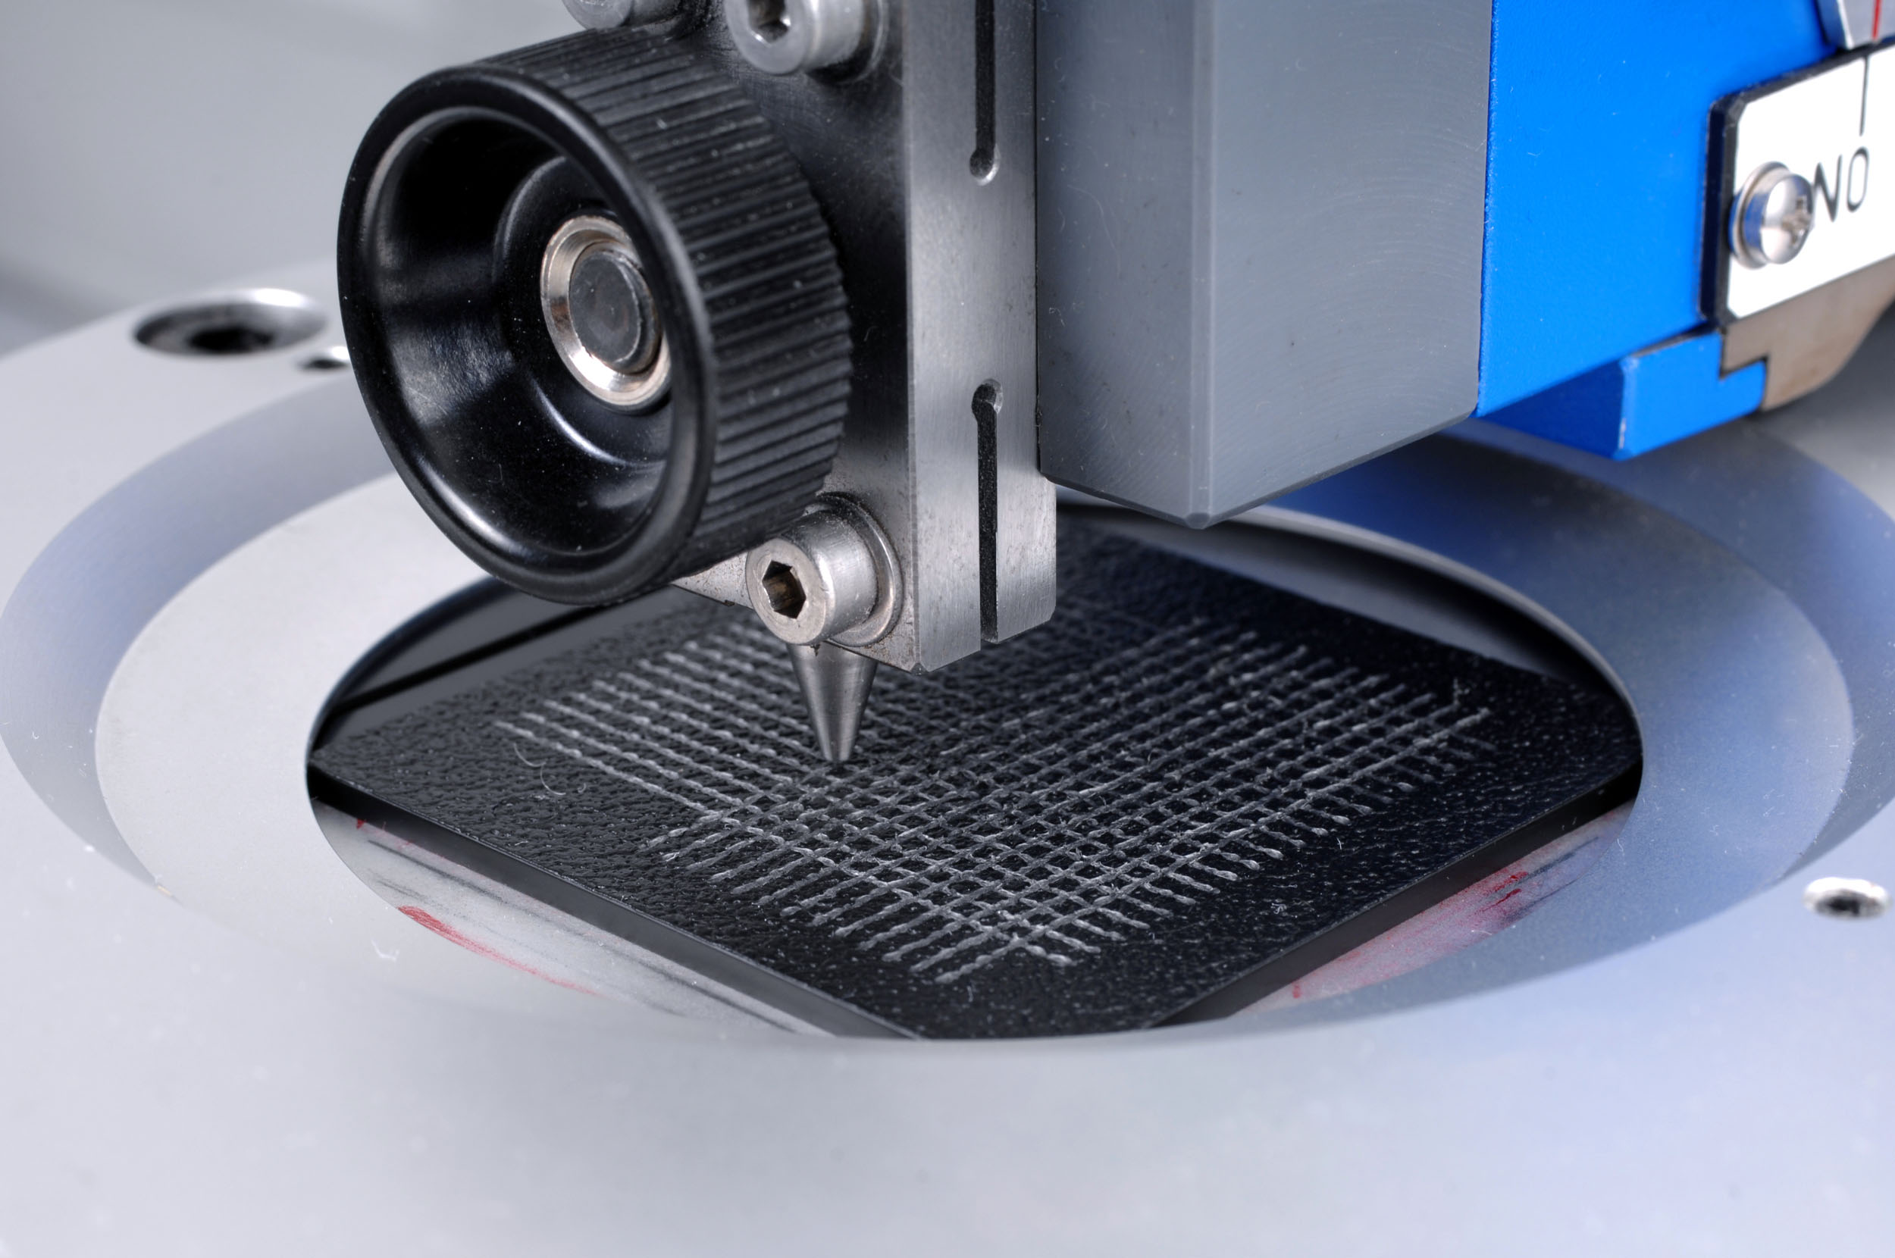

For more information
Detailed press releases on the comprehensive range of products and solutions offered by Evonik's business units are included in this press kit.

Electronic documents and photos can be downloaded at www.evonik.com/plastics.

Exceptional solutions in plastics are no exception for us
Working together with its customers and partners, Evonik develops products and system solutions for and with plastics. We thus have a range of services that satisfies market and application requirements.

Evonik is present in all major growth markets around the globe. Its customized products and solutions include raw materials, sophisticated additives and paints, engineering plastics, high-performance polymers, and semi-finished products. They are virtually exactly what is needed for tomorrow’s efficient, sustainable, and environmentally friendly ideas.

About Evonik
Evonik Industries is the creative industrial group from Germany. In our core business of specialty chemicals, we are a global leader. In addition, Evonik is an expert in power generation from hard coal and renewable energies, and one of the largest private residential real estate companies in Germany. Our company’s performance is shaped by creativity, specialization, continuous self-renewal, and reliability.

Evonik is active in over 100 countries around the world. In its fiscal year 2009 about 39,000 employees generated sales of about €13.1 billion and an operating profit (EBITDA) of about €2.0 billion.

Disclaimer
In so far as forecasts or expectations are expressed in this press release or where our statements concern the future, these forecasts, expectations or statements may involve known or unknown risks and uncertainties. Actual results or developments may vary, depending on changes in the operating environment. Neither Evonik Industries AG nor its group companies assume an obligation to update the forecasts, expectations or statements contained in this release.

