October 28, 2010

Dr. Philipp Tomuschat
Phone +49 201 173-2285
Fax +49 201 173-1989
philipp.tomuschat@evonik.com
Evonik Goldschmidt GmbH
Goldschmidtstrasse 100
45127 Essen
Phone +49 201 173-01
www.evonik.de

Supervisory Board
Patrik Wohlhauser, Chairman
Executive Board
Dr. Claus Rettig (Spokesman)
Willibrord Lampen

Registered Office Essen
Register Court
Essen Local Court
Commercial Registry B 18271
K 2010, Hall 6, Stand B 28

TEGOMER® FR 100

With TEGOMER® FR 100, an additive, it is possible to manufacture high-fill HFFR (halogen-free flame-retardant) cable compounds. It ensures that inorganic fillers such as ATH are evenly distributed in the polymer matrix and are thoroughly wetted by the base polymer. The result is a cable with a smooth surface that can be printed on without a hitch and can be manufactured at a higher rate of production.

The general trend away from PVC as a material for cable sheathing toward halogen-free materials such as PE or EVA is continuing uninterrupted. This is accompanied by efforts to replace additives containing halogen for flame-resistance with inorganic fillers. The aim of these changes is to make available cable materials that meet modern requirements with regard to smoke generation and flame-retardant properties. Low smoke and fume (LSF) and low-smoke, zero halogen (LSZH) are, for example, two of the requirements that are currently commonly in demand. One can meet these standards by incorporating into the polymer inorganic fillers such as aluminum hydroxide (ATH) or magnesium hydroxide (MDH) at a level of >60 percent. Having high concentrations of filler, which amounts to more than half of the compound, does create some technical challenges though. The flowability of such compounds is noticeably reduced, which negatively impacts the rate of production and may produce a very rough cable surface. In addition, the mixture is abrasive, which puts a lot of strain on machine parts so they wear out faster.

Currently, silicone oils or silicon oil master batches are used as internal lubricants to combat this problem. The purpose of this additive is to reduce friction, which improves flowability and, consequently, the cable properties. The disadvantage of these additives is that they are not bonded to the polymer matrix and may migrate to the surface where they form a film. This makes it difficult or impossible to print the instructions that are frequently required on the cable.

With our new TEGOMER® FR 100 additive high-fill cable compounds can now be manufactured without having to deal with the objectionable side effects caused by silicone oil. Chemically, TEGOMER® FR 100 is an organically modified siloxane that has comparable lubricating properties to silicone oil, but is firmly bonded with the polymer matrix thanks to its organic groups. This makes migration to the surface impossible. In addition, the additive ensures that the individual particles of the inorganic filler disperse very well, thus improving the flame-retardant properties.

The combination of good lubricating properties, anchoring in the polymer matrix, and fine dispersal allows high rates of production, a smooth cable surface, and excellent printability, which, combined with the required flame protection, is setting the new standard.

Caption:
High-fill cable compound with and without TEGOMER® FR 100

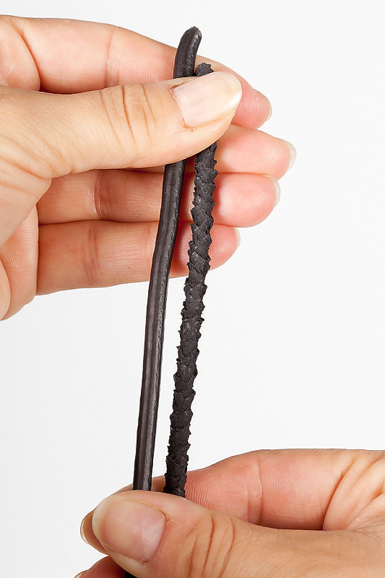

For more information
Detailed press releases on the comprehensive range of products and solutions offered by Evonik's business units are included in this press kit.

Electronic documents and photos can be downloaded at www.evonik.com/plastics.

Exceptional solutions in plastics are no exception for us
Working together with its customers and partners, Evonik develops products and system solutions for and with plastics. We thus have a range of services that satisfies market and application requirements.

Evonik is present in all major growth markets around the globe. Its customized products and solutions include raw materials, sophisticated additives and paints, engineering plastics, high-performance polymers, and semi-finished products. They are virtually exactly what is needed for tomorrow’s efficient, sustainable, and environmentally friendly ideas.

About Evonik
Evonik Industries is the creative industrial group from Germany. In our core business of specialty chemicals, we are a global leader. In addition, Evonik is an expert in power generation from hard coal and renewable energies, and one of the largest private residential real estate companies in Germany. Our company’s performance is shaped by creativity, specialization, continuous self-renewal, and reliability.

Evonik is active in over 100 countries around the world. In its fiscal year 2009 about 39,000 employees generated sales of about €13.1 billion and an operating profit (EBITDA) of about €2.0 billion.

Disclaimer
In so far as forecasts or expectations are expressed in this press release or where our statements concern the future, these forecasts, expectations or statements may involve known or unknown risks and uncertainties. Actual results or developments may vary, depending on changes in the operating environment. Neither Evonik Industries AG nor its group companies assume an obligation to update the forecasts, expectations or statements contained in this release.

