K 2010, Hall 6, Stand B 28
October 28, 2010

Dr. Ursula Keil
Marketing Support High Performance Polymers
Phone +49 2365 49-9878
Fax +49 2365 49-809878
ursula.keil@evonik.com

Photovoltaics from the Roll

- Barrier films from Evonik Industries are weather-resistant and highly transparent

A new type of solar barrier film developed by Evonik is making the production of flexible solar modules more profitable. Using the barrier film as the front cover makes it possible to produce thin-film solar modules cost-effectively in a roll-to-roll manufacturing process. The plastic film has similar barrier properties to the glass plates used in the past: Not only is it weather and UV-resistant, it is also highly transparent. This combination permits low-cost, efficient thin-film technology with a long life.

Up to now, suitable films that protect the thin-film solar cells from environmental damage in the long term have not been commercially available. The solution features a multilayer film consisting of barrier layers, plus a covering film that is UV-resistant on the outer layer. This efficiently protects the underlying functional layers and hence the solar cells from the weather.

The weight of the thin-film modules, which are now two-thirds lighter, provides new options for photovoltaic installations. Flat roofs, which for static reasons are currently not deemed suitable for supporting the heavy, rigid solar modules, will become a possibility. The flexible modules could also be installed on vehicle roofs and laptops, reducing fuel consumption for drivers and sparing laptop users the hassle of searching for a socket.

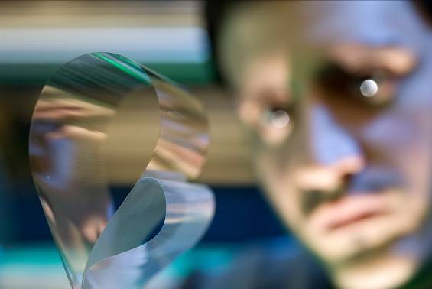
Caption:
Weather-resistant and highly transparent: Evonik’s barrier film makes the production of flexible solar modules profitable.

For more information
Detailed press releases on the comprehensive range of products and solutions offered by Evonik's business units are included in this press kit.

Electronic documents and photos can be downloaded at www.evonik.com/plastics.

Exceptional solutions in plastics are no exception for us
Working together with its customers and partners, Evonik develops products and system solutions for and with plastics. We thus have a range of services that satisfies market and application requirements.

Evonik is present in all major growth markets around the globe. Its customized products and solutions include raw materials, sophisticated additives and paints, engineering plastics, high-performance polymers, and semi-finished products. They are virtually exactly what is needed for tomorrow’s efficient, sustainable, and environmentally friendly ideas.

About Evonik
Evonik Industries is the creative industrial group from Germany. In our core business of specialty chemicals, we are a global leader. In addition, Evonik is an expert in power generation from hard coal and renewable energies, and one of the largest private residential real estate companies in Germany. Our company’s performance is shaped by creativity, specialization, continuous self-renewal, and reliability.

Evonik is active in over 100 countries around the world. In its fiscal year 2009 about 39,000 employees generated sales of about €13.1 billion and an operating profit (EBITDA) of about €2.0 billion.

Disclaimer
In so far as forecasts or expectations are expressed in this press release or where our statements concern the future, these forecasts, expectations or statements may involve known or unknown risks and uncertainties. Actual results or developments may vary, depending on changes in the operating environment. Neither Evonik Industries AG nor its group companies assume an obligation to update the forecasts, expectations or statements contained in this release.

