K 2010, Hall 6, Stand B 28
October 28, 2010

Dr. Ursula Keil
Marketing Support High Performance Polymers
Phone +49 2365 49-9878
Fax +49 2365 49-809878
ursula.keil@evonik.com

LEDs Shine Brightly for Longer

- Reflector sockets with VESTAMID® HTplus do not turn yellow.

Reflector sockets have a significant influence on the quality of LEDs. The whiter the reflector socket, the higher the reflectivity and the greater the luminous efficacy. Sockets made of VESTAMID® HTplus, a polyphthalamide PA10T developed by Essen, Germany-based Evonik Industries, remain pure white for a longer period, so the LED continues to shine brightly, generating a consistently high light yield. This gives the LEDs a much longer life. In addition, VESTAMID® HTplus is particularly environmentally friendly because 50 percent of the polymer is based on renewable raw materials.

Conventional reflector sockets turn yellow over time due to the effect of light and heat. As a consequence, the reflectivity and the luminous efficacy are continuously diminished until the light-emitting diode ultimately needs to be replaced. This is not the case for sockets made of VESTAMID® HTplus on account of the very bright inherent color of the material coupled with its outstanding UV stability. Thanks to its low water absorption, VESTAMID® HTplus also boasts better dimensional stability, which makes it easier to process and makes it suitable for use in particularly small LEDs. The miniaturization trend is also supported by the excellent adhesion to metal and silicon.

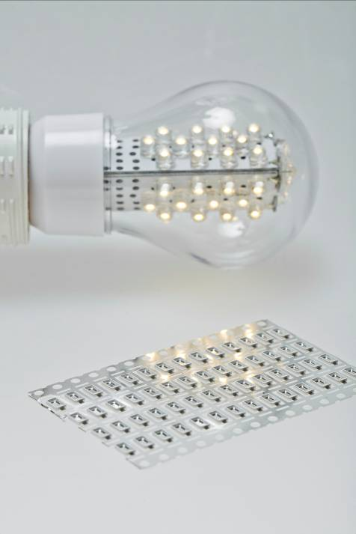
Caption:
Size comparison: Even tiny LEDs can be produced with reflector sockets made of VESTAMID® HTplus.

For more information
Detailed press releases on the comprehensive range of products and solutions offered by Evonik's business units are included in this press kit.

Electronic documents and photos can be downloaded at www.evonik.com/plastics.

Exceptional solutions in plastics are no exception for us
Working together with its customers and partners, Evonik develops products and system solutions for and with plastics. We thus have a range of services that satisfies market and application requirements.

Evonik is present in all major growth markets around the globe. Its customized products and solutions include raw materials, sophisticated additives and paints, engineering plastics, high-performance polymers, and semi-finished products. They are virtually exactly what is needed for tomorrow’s efficient, sustainable, and environmentally friendly ideas.

About Evonik
Evonik Industries is the creative industrial group from Germany. In our core business of specialty chemicals, we are a global leader. In addition, Evonik is an expert in power generation from hard coal and renewable energies, and one of the largest private residential real estate companies in Germany. Our company’s performance is shaped by creativity, specialization, continuous self-renewal, and reliability.

Evonik is active in over 100 countries around the world. In its fiscal year 2009 about 39,000 employees generated sales of about €13.1 billion and an operating profit (EBITDA) of about €2.0 billion.

Disclaimer
In so far as forecasts or expectations are expressed in this press release or where our statements concern the future, these forecasts, expectations or statements may involve known or unknown risks and uncertainties. Actual results or developments may vary, depending on changes in the operating environment. Neither Evonik Industries AG nor its group companies assume an obligation to update the forecasts, expectations or statements contained in this release.

