K 2010, Hall 6, Stand B 28
October 28, 2010

Dr. Ursula Keil
Marketing Support High Performance Polymers
Phone +49 2365 49-9878
Fax +49 2365 49-809878
ursula.keil@evonik.com

Digital Layer Construction by Evonik

- Additive manufacturing holds untapped potential, particularly for low-volume production.

Extrusion and injection molding are not always the best way to mold plastics. An alternative is mold-free production, so called Additive Manufacturing (AM), which combines maximum flexibility with high customer orientation and cost efficiency. With laser sintering, for example, it can produce complex and technically demanding industrial and consumer goods from high-tech plastics. Evonik Industries, Essen, offers powders customized to this technology, e.g., polyamide 12 powders, and looks back on a well-known competency for many years.

For Additive Manufacturing, for example, powders are layered to build three-dimensional structures without the use of a mold. In the laser sintering process, which is am AM process, containers are filled with fine plastic powder. A laser located above the powder bed lights only certain areas of the uppermost particle layer and melts these areas. An automatic mechanism then lowers the floor of the powder container by fractions of millimetres, and spreads a fresh layer of particles. Again, the laser lights this layer only in certain places. The result of this method is a spatial component built of ultra-thin layers, whose complexity is limited by almost nothing but the specified electronic construction data.

Thermoplastics are ideal for additive manufacturing: they are easy to pulverize, can be selectively melted, and their chemical and physical properties can be customized. At Evonik, experts have spent roughly ten years developing thermoplastics for AM. For example, Evonik developed an ultra-flexible polyamide (PA) that has eight times the flexibility and five times the tensile strength of the standard material. Another development, namely PEEK powder for laser sintering, stands out for its high melting point of 340 °C, which makes it suitable for parts exposed to high temperatures during operation. Optimized polymers like this enable new functionalities, while at the same time creating ways of replacing other materials, such as metals, with plastics.

Additive Manufacturing uses no casting molds, tools or space consuming production plants. Components are created directly from a digital construction plan. This enables the production of forms that have been long considered impossible by conventional series production—in fact, they can be created fast, flexibly, and with fewer machines. This is why additive manufacturing has been a long time particularly common in prototype construction. An increasingly important field is the low-volume production, e.g., of headlight housing for high-priced cars, steering components for vehicles driven from the right side, and housing for specialty machines. For these products, conventional mass production with its costly molds and large plants is simply too expensive.

Another field of application is individually modified components. Examples include not only medical devices such as hearing aids, implants or surgical instruments, and drill guides for operations, but also helmets and shoes for professional sports and respirator masks. Variants are handled exclusively through software solutions—from the capture and processing of the individual data, to a single set of construction data for each part. And also designers recognized the worth of the free-form fabrication.

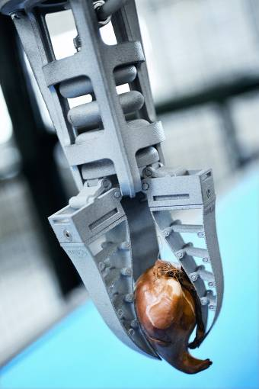
Caption:
Produced by selective laser sintering, the FinGripper of Festo AG & Co. KG, Esslingen, is light, flexible and adaptable. Like the human hand, it adjusts itself to the shape of the object to be gripped. It is produced by applying layers of polyamide powder 0.1 mm thick on top of each other and selectively melting them by laser.
Photo: Festo AG & Co. KG, Esslingen

For more information
Detailed press releases on the comprehensive range of products and solutions offered by Evonik's business units are included in this press kit.

Electronic documents and photos can be downloaded at www.evonik.com/plastics.

Exceptional solutions in plastics are no exception for us
Working together with its customers and partners, Evonik develops products and system solutions for and with plastics. We thus have a range of services that satisfies market and application requirements.

Evonik is present in all major growth markets around the globe. Its customized products and solutions include raw materials, sophisticated additives and paints, engineering plastics, high-performance polymers, and semi-finished products. They are virtually exactly what is needed for tomorrow’s efficient, sustainable, and environmentally friendly ideas.

About Evonik
Evonik Industries is the creative industrial group from Germany. In our core business of specialty chemicals, we are a global leader. In addition, Evonik is an expert in power generation from hard coal and renewable energies, and one of the largest private residential real estate companies in Germany. Our company’s performance is shaped by creativity, specialization, continuous self-renewal, and reliability.

Evonik is active in over 100 countries around the world. In its fiscal year 2009 about 39,000 employees generated sales of about €13.1 billion and an operating profit (EBITDA) of about €2.0 billion.

Disclaimer
In so far as forecasts or expectations are expressed in this press release or where our statements concern the future, these forecasts, expectations or statements may involve known or unknown risks and uncertainties. Actual results or developments may vary, depending on changes in the operating environment. Neither Evonik Industries AG nor its group companies assume an obligation to update the forecasts, expectations or statements contained in this release.

